Winston Road, Churchdown, Gloucester, GL3 2RB
Telephone 01452 713340
E-mail: school@churchdownschool.com
Website: www.churchdownschool.com

Headteacher: David Potter
ACHIEVING SUCCESS FOR ALL

Churchdown School Academy
The Churchdown School Academy Trust is a company incorporated in England and Wales operating as a charity and limited by guarantee with registered Company Number 7773693 Registered Office: Winston Road, Churchdown, Gloucester, GL3 2RB

APPLICATION FOR ABSENCE FROM SCHOOL IN ‘EXCEPTIONAL CIRCUMSTANCES’

If requesting a leave of absence you will need to complete the form on the reverse of this notice, setting out the reasons. If the holiday is not considered to be an exceptional circumstance it will not be agreed. If you nevertheless take your child out of school for the leave of absence this will be recorded as unauthorised leave.

In the case of unauthorised leave of absence, the headteacher may request that the Local Authority issue a Fixed Penalty Notice without further warning to the parent. Please note that such a penalty is issued to each parent for each child taken out of school. A Penalty Notice is a fine of £60 if paid within the first 21 days and increases to £120 if paid between 21 and 28 days. Thereafter, if the penalty remains unpaid, this may lead to prosecution through the Magistrates’ Court.

------------------------------------------------------------------------------------------------------------------
REQUEST FOR LEAVE OF ABSENCE DURING TERM TIME

I would like the school to consider my application for the exceptional circumstances outlined on the reverse. (Please give reasons for your request using the box on the reverse of this letter)

CONTACT DETAILS FOR PARENTS/CARERS

 | Parent / Carer Number 1 | Parent / Carer Number 2
Name
Phone Number
Email Address

DETAILS OF CHILDREN

 | Name | Tutor Group
First Child
Second Child
Third Child

FOR SCHOOL USE ONLY

AUTHORISED |  | NOT AUTHORISED |  | CURRENT ATTENDANCE (%)
SIGNED |  |  |  |  | DATE
Having attended the Parents’ Information Evening in Term 1, I am aware of the school’s views on taking children out of school during term time. I understand that taking my child/children out of school may have a detrimental effect on their education. I also understand that the school’s attendance policy states that absence during term time will only be authorised in exceptional circumstances and that the Local Authority may issue a fine in some circumstances.

I understand that if the absence request is not authorised but the holiday is taken, the headteacher may request that the Local Authority issue a Fixed Penalty Notice. I understand that a Penalty is issued to each parent for each child taken out of school.

I would like the school to consider my application for the following exceptional circumstances outlined below.

FIRST DAY OF ABSENCE |  | LAST DAY OF ABSENCE |  | NUMBER OF SCHOOL DAYS REQUESTED

Please ensure that you allow sufficient time for your request to be processed (we suggest three weeks). School will reply to your request by email.

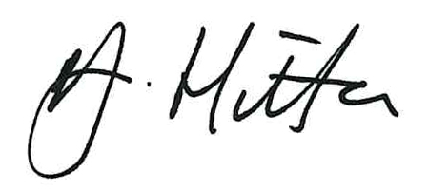
Ms J Hilton
Deputy Headteacher

