Application for Internal Students Churchdown Sixth Form 2020

Name
Address
Date of Birth
Best contact phone number
Student’s email

Current
ISMs

Subject | Target | Current ISM
English

Maths

Please complete the table below providing your current ISM grades and targets for every subject you are currently studying

Predicted Average GCSE Grade
Using your current ISMs please supply your predicted average grade score.

Average GCSE score
Your average GCSE grade can be created through adding together all your GCSE ISM grades and divided by the number of subjects you study. An example can be found in the Entrance Criteria booklet.
Please indicate below three subjects from the Four Option Blocks. Four subjects are optional for the Academic Pathway students only. Please note you are not bound to these choices but it is most helpful for our planning to ensure we can accommodate your preferred options.

Block A | Block B | Block C | Block D

Subjects

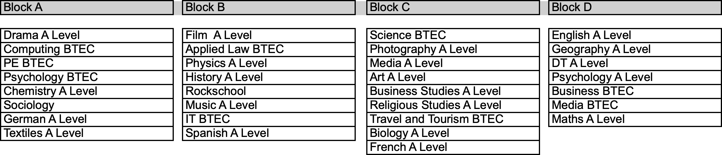

*For reference Maths and English GCSE will be in Block A and Block B

Comments
If there is a specific combination of subjects required for your future career path that is not available within these option block.
Please use this space to tell us:
- Your chosen career path

- The combination of subjects you need to study

Completed forms can be returned to:

Mrs Whitson-Jones, Churchdown Sixth Form, Winston Road, GL3 2RB.

Application forms should be returned no later than Friday 14th February 2020

Contact details:

Head of Sixth Form: Mrs Whitson-Jones

Email: miw@churchdownschool.com

