
Transition Pack
BTec Sport and Exercise Science
Level 3
Mandatory Tasks
Task | Page No. | Completed (tick) | Score (if applicable)
Pre-knowledge tasks – Introduction | 2-4
Unit 2 Functional Anatomy –  Tasks 1-6 | 5-7
Unit 3 Applied Sport & Exercise Psychology - Tasks 7&8 | 8-11
Unit 6 Coaching for Performance & Fitness  Task 9 | 12-21
Recommended Texts
Task | Page No.
Book, movie, online videos and podcast recommendations  Movie Recommendations | 21
KEY WORDS | 22

Contacts:
Mr Letori - jol@churchdownschool.com
Mr Oliver – jeo@churchdownschool.com
Miss Tandy sgt@churchdownschool.com
Mrs Langton hgl@churhcdownschool.com

Introduction

This series of tasks and activities are designed to give you an insight into the BTec Level 3 Extended Certificate in Sport and Exercise Science course. As part of the transition from year 11 GCSE PE to Level 3 BTec Sport and Exercise Science it is important to develop a greater understanding of certain aspects of the course which will help you over the next two years. Please complete the following booklet.
A percentage of the topics we will cover, haven’t been studied in GCSE PE so the information will be new to all students. It is however essential you are aware of the step up from key stage 4. It is an expectation that you are involved in competitive sport.
Name

School

Do you play sport?

If yes to the question above;
Team & League/Competitions

Other commitments e.g. part time jobs/gym membership

This booklet has been prepared by the PE department for you to read and the work contained in it will ensure that you get off to a positive start in this subject area. It is very important that you read this booklet carefully over the summer and attempt to complete the work to the best of your ability and submit it to your teacher. This will be the first impression you create and is a real indicator of how seriously you are prepared to be in your studies.

COURSE OUTLINE

Eligibility for awards;
In ordered to be awarded a qualification a learner must complete all units and achieve a pass or above in all mandatory units.

To achieve any qualifications grade, learners must;
1. Complete and have an outcome Distinction, Merit, Pass, Ungraded (D, M P and U) for all units with a valid combination.

2. Achieve the required units at pass or above and for the Extended Certificate achieve a minimum of 360 GLH at a pass or above.

BTEC LEVEL IN SPORT & EXERCISE SCIENCE
At a Glance

Course Details

Course Title: BTEC National in Sport & Exercise Science Level 3

Exam board: Edexcel/Pearson

Exam Board web site:
www.edexcel.com
www.btec.co.uk

Assessment method: The BTEC Sport Level 3 qualification is assessed both externally and internally via coursework based assignments.

The pathway you will study at Churchdown is the Extended Certificate which is equivalent to an A Level qualification.

Unit 2 – Functional Anatomy: is a written exam for 1.5 hours, worth 60 marks. This will be set and marked by Pearson, with 1 re-take allowed.

Unit 3 –Applied Sport & Exercise Psychology: is the second externally assessed unit where pre-released information is released 1 week prior to a controlled assessment in exam conditions. 1 week prior to the assessment learners will receive information within controlled conditions where 4 hours can be spent preparing information. After this, on a date specified by Pearson, learners will then spend a further 3 hours applying this within controlled exam conditions.

About the course

There has been significant increases in the popularity of BTec Sport & Exercise Science Level 3 since 2010. This has been driven by increased investment, publicity (Olympics), and subsequent vocational opportunities. With a third of workers in this sector having no formal qualifications beyond Level 1, many employers complain they cannot fill vacancies because of the skills shortage. This course exists to enable learners to be at the forefront of sport where these opportunities exist. Units are tailored to the needs of learners and the Sports sector (e.g. Sports Coaching).

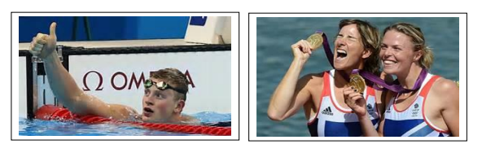

ASSESSMENT POLICY
External assessment (Unit 2 Functional Anatomy, Unit 3 Applied Sport & Exercise Psychology):

Each external assessment for Btec National is linked to specific units. All of the units are developed for external assessment of 120GLH to allow learners to demonstrate breadth and depth of achievement. Each assessment is taken under specified conditions, then marked by Pearson and a grade is awarded. Learners must achieve all external units at pass grade or above. The styles of external assessment used for qualification in the sport suite are:

Examinations (Unit 2 Functional Anatomy) - all learners take the same assessment at the same time, normally with a written outcome.
Set tasks (Unit 3 Applied Sport & Exercise Psychology) – learners take the assessment during the defined window and demonstrate understanding through completion of a vocational task. Some external assessments include a period of preparation using set information.

External assessments are available once or twice a year and learners can only have one resit attempt during the programme.

Internal assessment (Unit 6 Coaching for Performance & Fitness & Unit 8 Specialised Fitness Training) - Each student is allowed ONE submission for each assignment. Therefore, it is crucial that you get it right first time and meet the required assessment criteria. You should make sure that you fully understand the assignment or assessment task that you have been issued. Don’t be afraid to ask your unit teachers for help if you don’t understand what you need.
So what happens if I don’t achieve the assessment criteria after my submission?
Due to every assignment contributing towards the final grade, you may be entitled to one opportunity for a resubmission to meet the assessment criteria. However, this has to be authorised by the Lead Internal Verifier and you must meet the following criteria:

- You met the initial deadline set for the assignment.
- Your teacher feels you can improve your evidence with no further guidance.
- You have signed and dated a declaration of authenticity for your assignment.

If these three conditions have not been met, you will not be authorised for a resubmission.
Should you be authorised for a resubmission, you will have 10 working days to complete the assignment from the date of receiving your feedback. You will not be given any additional guidance from your unit teacher. Get it right first time. Be prepared for your assignments!

What happens if my resubmission still doesn’t meet the pass criteria?
The qualification doesn’t allow for compensation, therefore students are required to pass every unit in order to gain the full qualification.

UNIT 2 – FUNCTIONAL ANATOMY – Mr Letori
Introduction
The human body is made up of many different systems that work together and allow us to take part in a huge variety of sport and exercise activities. An athlete can go from rest to all-out sprinting in a matter of seconds, whereas an endurance athlete can continue exercising for many hours at a time. The skeletal and muscular systems work together to allow our bodies to perform a vast range of different movements. Our cardiovascular and respiratory systems act as a delivery service, working together to supply oxygen and nutrients to the body which in turn is used to produce energy for muscular contraction.
In order to appreciate how each of these systems function, you will study the structure of the skeletal, muscular, cardiovascular and respiratory systems. The human anatomy of these systems is very different, but in terms of operation, each system is implicitly linked. Having an understanding of these body systems is imperative in the sport and active leisure industries in order to begin to appreciate how the body functions and how it copes with the many different stresses of exercise.
Scenario
University places are extremely hard to get onto these days. You have applied for a place on a sports coaching degree. You have been called for an interview for a place on the course you want so much. As part of the application you must demonstrate a knowledge and interest in the sport and the influences on performance. You have been given the topic of the Skeletal system to research and must be prepared to present and discuss fully in a discussion with an interview panel at the university.
Task 1
Using a Powerpoint prepare slides for your discussion with your tutor:
- Find a blank picture of the AXIAL skeleton and label it.
- Find a blank picture of the APPENDICULAR skeleton and label it.
For each you will be required to describe: (a) where it is located, (b) the bones that form part of the skeleton, (c) what the skeleton’s function and role is and (d) What movement it allows DO

NOT FORGET TO REFERENCE YOUR WORK AND PICTURES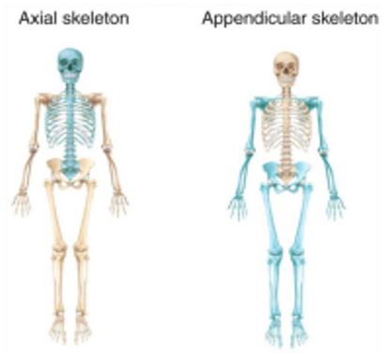

Task 2
Using a Powerpoint prepare slides for your discussion with your tutor on the following:
- The FIVE TYPES of bones: (1) Long Bones, (2) Short Bones, (3) Irregular Bones, (4) Flat Bones and (5) Sesamoid Bones.
- (1) Have a picture/diagram (of the bones and its structure/make up), (2) Purpose/Job, (3) Examples of bones in this category and where these examples are found and why they are placed in this category.
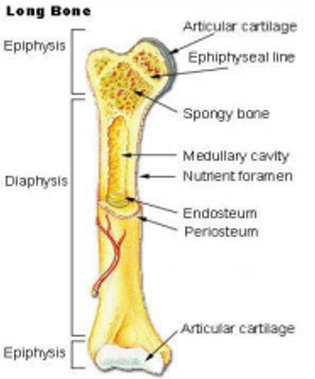
Task 3
Using a Powerpoint prepare slides for your discussion with your tutor on the following:
Find a blank picture of the skeleton and then identify the following 21 bones to include: cranium, clavicle, ribs, sternum, humerus, radius, ulna, scapula, ilum pubis, ischium, carpals, metacarpals, phalanges x 2, femur, patella, tibia, fibula, tarsals, metatarsals.
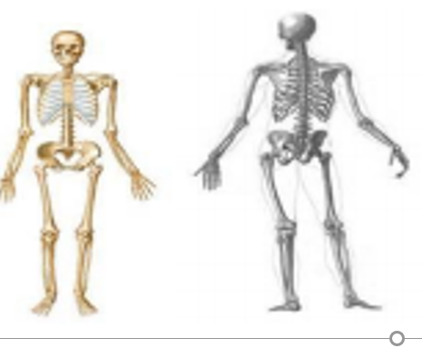
Task 4
Using a Powerpoint prepare slides for your discussion with your tutor on the following:
Find a blank picture of the Vertebral Column and then identify each of the following regions: Cervical, thoratic and lumbar vertebrae, sacrum, coccyx
For each region you will need to identify and know: (1) how many bones make up that region, (2) the function of the region, (3) identify where the Atlas and Axis bones are in the vertebral column and their function
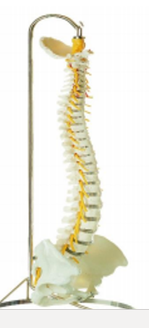

Task 5
Using a Powerpoint prepare slides for your discussion with your tutor on the following:
Prepare a slide for each of the FUNCTIONS OF THE SKELETAL SYSTEM wehich covers the following; (1) What it is, (2) How the skeleton provides it and (3) why the function is important/useful
THE FUNCTIONS: support, protection, attachment for skeletal muscle, sorce of blood cell production, store of minerals

Task 6
Answer the following questions on a Powerpoint slide/slides
- Explain how bones of the skeleton are used in movement for sport (2 marks)
- Describe the process of bone remodelling (3 marks)
- Identify the 6 types of synovial joint and give an example of where each one is located (6 marks)
- Explain the function of the axial and appendicular skeleton (4 marks)

UNIT 3 – Applied Sport & Exercise Science – Mrs Langton/Miss Tandy
Introduction
Sports psychology is increasingly prominent in modern sport. An individual’s psychological approach is often the key factor in successful sports performance and finding sport enjoyable. Understanding the different psychological factors that can affect sports participation and performance, as well as how to develop these qualities, is important for those working in the sports industry, such as athletes, tutors and coaches.
Task 7 - Please read the following text and answer the question below on motivation. use the link if required: https://www.pearsonactivelearn.com/app/library/series/view/714900#/studentbooks - USER NAME - Btecsport12 PASSWORD – Churchdown 1 – PAGE 82

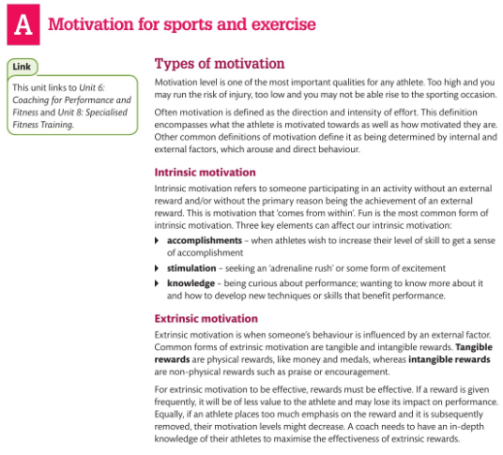
- What are the key differnces between intrinsic and extrinsic motivation ?
- Produce a table that provides exples of intrinsic and extrinsic motivation.
- How do you think intrinsic and extrinsic motivation can interact to influence sport performance both positively and negatively

Task 8 – Applied Theories of Psychology. Please research the recommended websites and books and answer the questions/‘fill in the gaps’ related to these various psychological theories and factors. The first one has been done for you as an example.

- For each psychological theory give a general overall summary.
- For each psychological factor summarise for a sporting example of your own choice

Example
Theory: Need Achievement Theory
• Individuals can be categorized into two groups in respect of motivation – the need to achieve and the need to avoid failure.
• Individuals in the need to achieve group tend to strive for success and take a pride in their accomplishments.
• Those in the need to avoid failure group are afraid to fail and avoid challenges and risks.
Psychological Factor: Motivation
•High Motivation is a key characteristic of successful sports performers, closely linked to arousal.
• A rugby players motivation could be intrinsic; they could be driven by the need to achieve; likes the feeling of winning; sense of achievement is a focus; uses it to help prepare for the next match; supports their success during training and matches; affects their ability to perform.
• Optimum levels of motivation before over-motivation takes place which can cause injury. Injury affects motivation negatively; as they realise recovery is possible, motivation returns with a positive impact.
Theory: Inverted U hypothesis
• States that there is an optimum level of arousal to .……………………………………………………………………………………………………………………………………………………………………………………………………………………………………………………………………………………………………………………………………………………………………………………………………………………………………………………………………...
Psychological factor: Arousal
• Self-regulation of arousal levels is a key characteristic of successful sports performers.
•It is clear that, prior to competing, an athletes is in a state of increased arousal, demonstrated by ………………………………………………………………………………………………………………………………………………………………………………………………………………………………………………………………………………………………………………………………………………………………………………………………………………………………………………………………………..
•Initially, the level of arousal has, ………………………………………………………………………………………………………………………………………………………………………………………………………………………………………………………………………………………………………………
• Then, ………………………………………………………………………………………………………………………………………….. ………………………………………………………………………………………………………………………………………………………..
Theory: Vealey’s multidimensional model of sport confidence
• Suggests that there are key areas that need to be fulfilled to promote self-confidence
• Factors such as …………………………………………………………………………………………………………………………… ………………………………………………………………………………………………………………………………………………………………………………………………………………………………………………………………………………………………………………...
Psychological factor: Self – confidence
• High levels of self-confidence are key characteristics of successful sports performers. It is important that an individual is self-confident in ……………………because ………………………………………………………………
…………………………………………………………………...................................
• A ……………. displays high confidence .……………………………………………………………………………………………...
………………………………………………………………………………………………………………………………………………………………………………………………………………………………………………………………………………………………………………...
• Significant personality change seen ……………………………………………………………………………………………………………………………………………………………………………………………………………………………………………………………………………………………………………….
Theory: Banduras social learning theory
• Explains that aggression is a behavior which is learned by observing others and ……………………………..
………………………………………………………………………………………………………………………………………………………...
• Reinforcement can be from anyone and ………………………………………………………………………………………….
………………………………………………………………………………………………………………………………………………………..
Psychological factor: Aggression
• Instrumental, controlled aggression is important to …………………………………………………………
………………………………………………………………………………………………………………………………………………………
• Aggression is suitable for , ………………………………………………………………………………………………………..
……………………………………………………………………………………………………………………………………………………….
Theory: Bandura’s self-efficacy theory
• Suggests than an individual beliefs about their capabilities to complete a task have a profound effect as to whether they are………………………………………………………………………………………………………………………
• The theory explains that there are four sources ……………………………………………………………………………...
………………………………………………………………………………………………………………………………………………………...

Psychological factor: Self-efficacy
• Positive thinking is a key characteristic of successful sports performers. Self-efficacy is closely linked to self-confidence.
• Self-efficacy is …………………………………………………………………………………………………………………….………………………………………………………………………………………………………………………………………………………………………………………………………………………………………………………………………………………………………………...

UNIT 6 – Coaching for Performance & Fitness – Mr Oliver
Introduction
There is more to being a good coach than producing athletes or excellent teams. The best coaches are those who give athletes a positive experience and motivate them to continue. The role of a sports coach can go beyond that of a skilled and knowledgeable coach who is dedicated to developing athletes. A coach might be called on to act as a fitness trainer, social worker, motivator, disciplinarian, friend, mentor, manager or secretary, as many other roles. With sports participation increasing throughout the U, there is a strong demand for coaches who can develop athletes’ performance and fitness.
Task 9 - Please read the following text below: use the link if required:
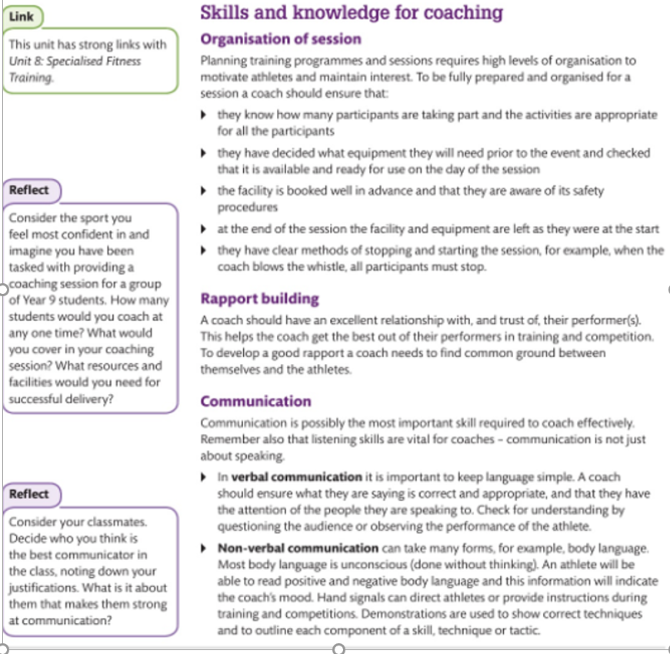
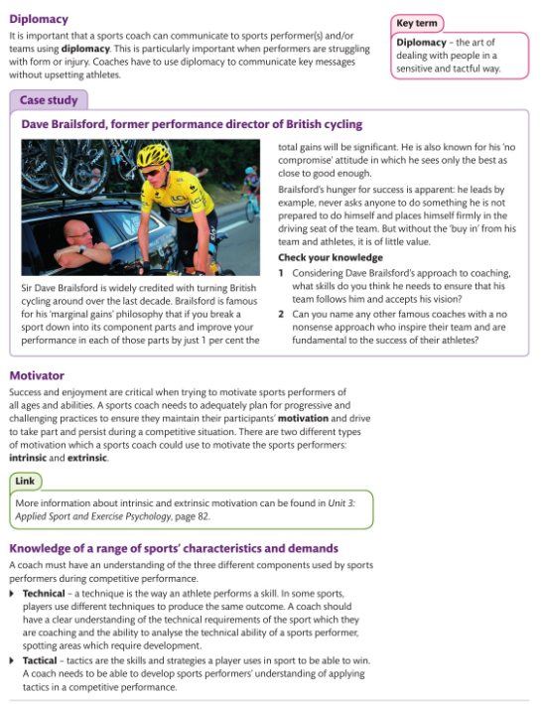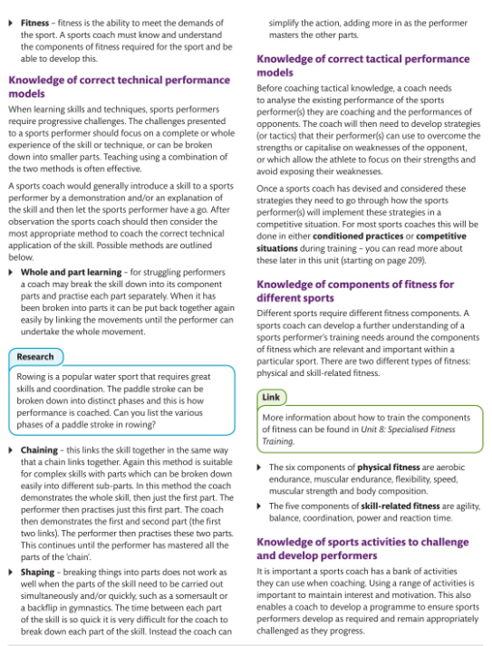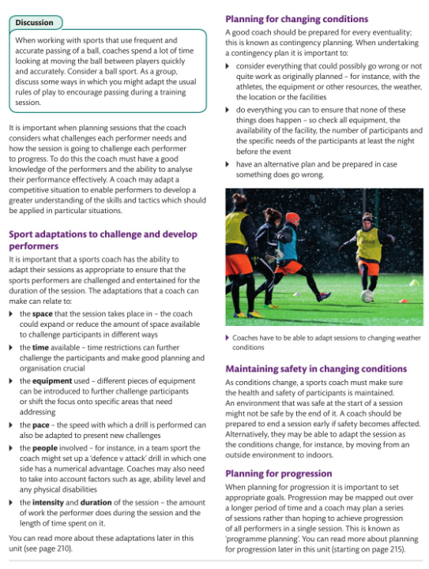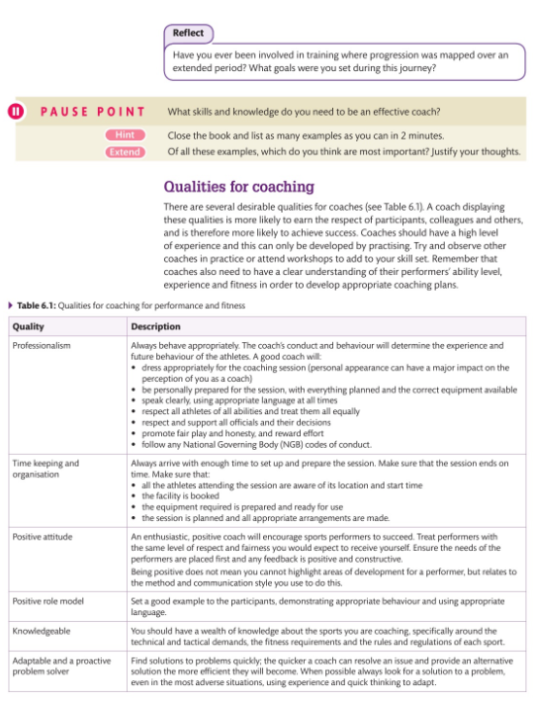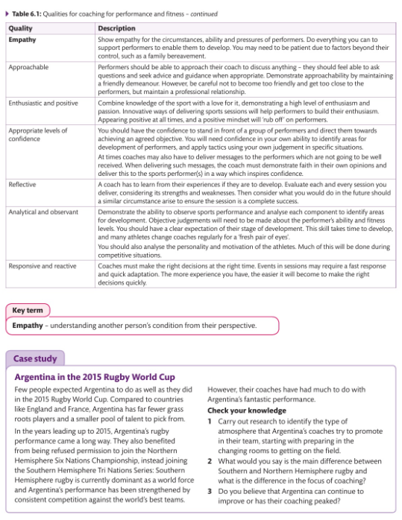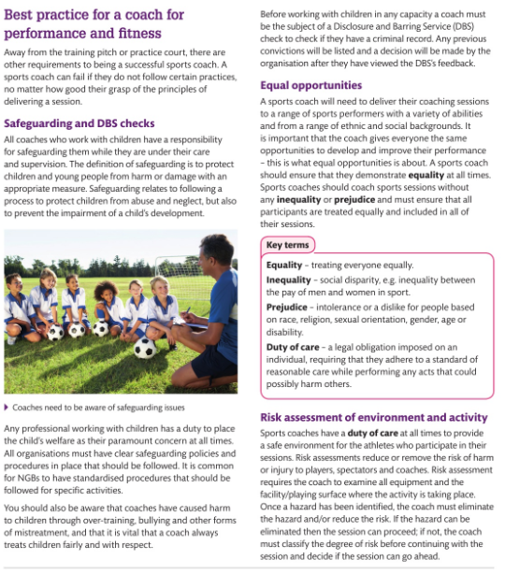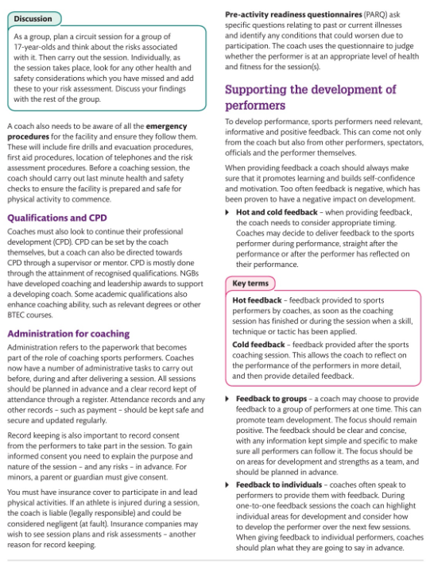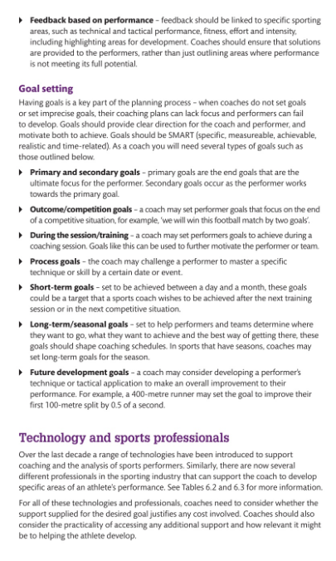

LISTEN, WATCH, READ, STUDY
  Complete this MOOC.  Football: more than a game  University of Edinburgh  This course is open now! |   Listen to this radio programme from the BBC World service. Sports Hour is a live Saturday morning sports show with reports, debate and humour. There are over 280 shows available covering all world sport.  BBC World Service: Sports hour  BBC Programmes |   Read this article which explores the science behind wearing a helmet in sporting activities and how helmets are there to stop brain fracture and not concussion.  Football helmets don't protect against concussion - and we're not sure what does  Ideas TED |   Watch this TED talk  which explores how racial stereotypes have infiltrated the language we use to discuss athletes.  Shouldn’t sports be colour-blind  TED Talks – Patrick Ferrucci | Complete this course.  Exercise prescription for the prevention and treatment of disease  Future Learn  Available now or 4th May 2020
Listen to this radio programme.  This is a daily podcast bringing you the latest from the Premier League, EFL, European football and more.  BBC Radio 5 Live  BBC Programmes | Read this article  which explores some of the key gender issues in sports.  Sports are designed around men – and that needs to change  Ideas TED | Watch this TED talk.  Are athletes really getting faster, better, stronger?  TED Talks – David Epstein | Listen to this podcast in which Calum and Buncey react to KSI's split-decision victory over Logan Paul in Los Angeles.  KSI vs Logan Paul II  BBC Sounds | Watch this TED talk.  My 12 pairs of legs  TED Talks – Aimee Mullins
Watch this TED talk in which Valorie Kondos Field, long-time coach of the UCLA women's gymnastics team, shares the secret to her success. Hint: it has nothing to do with "winning."  Why Winning doesn’t always equal success  TED Talk – Valorie Kondos | Watch this TED talk in which Christopher McDougall explores the mysteries of the human desire to run.  Are we born to run?  TED Talk – Christopher McDougall | Watch this TED talk. How much do you know about intellectual disabilities?  Special Olympics let me be myself – a champion  TED Talk – Matthews Williams | Watch this TED talk.  Amazing, inspiring feats of daring and determination that will bring you everywhere from the high skies to the deep sea. (Playlist of eight talks).  Extreme sports  TED Talks | Listen to this podcast from the British Journal of Sports Medicine. It covers all sorts of aspects of Sports Medicine, from the science behind running shoes to the power of sleep.  BJSM Podcast  Also available on other podcast providers – search ‘BJSM’

READING LIST



KEY TERMS FOR ASSIGNMENTS & EXAMS


