
Transition Pack
For
BTEC Creative Media

Mandatory Tasks
Task | Page No. | Completed (tick) | Score (if applicable)
Textual Analysis – Armani Code | 5 - 9
Stereotypes | 13 - 14
Scene Analysis | 19
Video Killed the Radio Star | 26

Optional Tasks
Task | What did you read, see or do?
Book recommendations
Movie Recommendations
Online video/article recommendations

Welcome to BTEC
Creative Media
Media studies is a vital part of society. Media is all around us and the media is becoming more prevalent in the work place so I cannot stress how important the content of this subject is. Whatever job or career you go in to in the future it will have some involvement with the media and we must consider how the media operate in order to understand its power in the world we live in.
What is the media? Day one of year 12 I will ask you this question. No doubt throughout this booklet you will have a good sense of what it is but before you begin please write down your thoughts or a definition in the space below. We will go one step further to consider if the media is a good or a bad thing? Try to do some research to establish how you feel about the media and its use in current society. Think of it from a producer’s point of view, and a consumers.
What is the media?

Creative media studies is assessed over 4 units throughout the year. You will have two external units which you will have two attempts at (if needed). The internal units centre on the production of a film that you will create from initial concept to editing your final piece. You will consider all of the external factors in the production such as financing and legal requirements. You can find examples of these videos from ex students on the media hub along with samples of the tasks you must complete.
www.churchdownmediahub2.com password – churchdownmediahub
Unit 1
Media Representations | External Exam
Unit 4
Pre-Production Portfolio | An in depth look at the film production process
Unit 8
Responding to a commission | External coursework unit
Unit 10
Film Production | Produce your own film product

Resources
At Churchdown we are product to be able to offer you a fully integrated and accessible on line learning platform in the form of ‘the churchdown media hub’. This should be accessed daily as a media student completing independent work, pre-reading and accessing the resources for assessments and coursework units. Each page is loaded with key information on each of the set products, sample answers, models, videos and opportunities to develop your knowledge beyond the set curriculum.
www.churchdownmediahub.com
password – churchdownmediahub
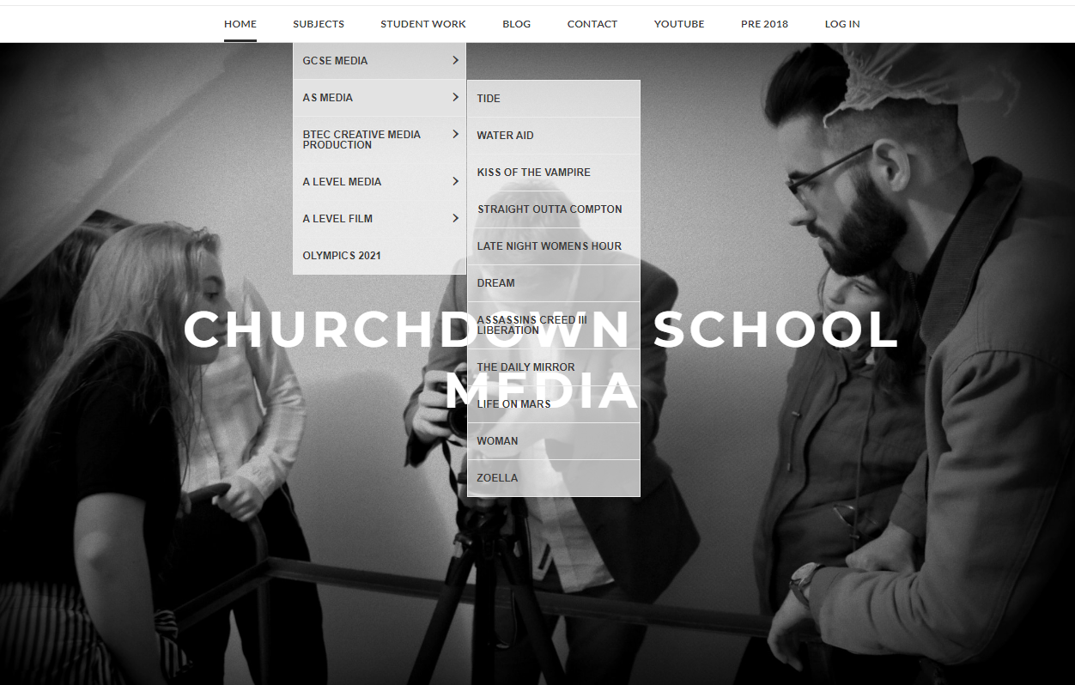
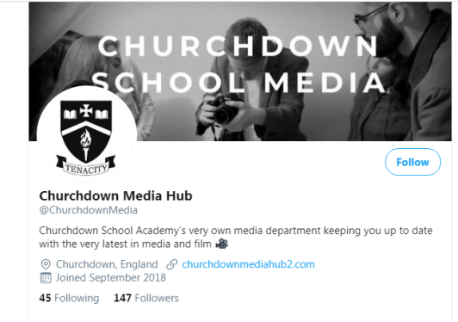
Our twitter account is also extremely popular and useful for communication with teachers, access to wider resources and to further deepen your knowledge within the subject. We strongly recommend that as a sixth form student in media you follow this account and engage with the content. Feel free to share anything you feel may be of interest to the media cohort at Churchdown School.
Follow the link below to the BTEC home page where you can access specifications and further examples of sample work. https://qualifications.pearson.com/en/qualifications/btec-nationals/creative-digital-media-production-2016.html


Media Language
Media language is the key starting point for studying media studies. It is the way the media communicates with the audience. This can of course be verbal but also non-verbal in a large number of cases. Facial expressions, colour, clothing, lighting, camera angles, body language all communicate meaning and it is up to us studying media to try and understand the meaning being communicated by what we see. Before we look at some examples take a look at some of the key words in this area of the theoretical framework.
Research the meaning of each word and write the definition in the space provided.
Denotation
Connotation
Semiotics
Symbolic Codes
Preferred Reading
Polysemy
Encoding
Decoding
Anchorage
Target Audience

There is one big issue with the use of media language and it is the same as the spoken language. Not all things mean the same to different people. For example; the word chicken may make you think of the bird which you see on a farm laying eggs but the word can also be used to describe someone who is scared. So if a producer of the media chose to use the word chicken they would need to be careful on the context in which it was used in order to generate the correct response from the audience.
Textual Analysis Task
Let’s take a look at this fiat 500 advert. Follow the steps to analyse this text.
1 – Identify the elements of media language used. (Colours, text, model – body language, clothes)
2 – For each one consider what they are saying about the car and the people they want to buy it
3 – Piece together all these elements to create a cohesive message intended for the audience by the media producers.
Remember this… the point of the advert is to sell the car so the message is intended for its target audience. If you don’t get the message you may simply not be the target audience but we must try to analyse the text by breaking down the use of media language.

Text – Compares car to clothing or accessory and this is a fun car to have. Implies you are not boring if you drive this car.

Layout – Finer details about the car in smaller font but laid out similar to that of a fashion magazine to continue theme of fashion and style

Model – Position and clothing again reflect that of a model seen in a fashion magazine further supporting the cars appeal. Female could suggest target audience

Text – further links to clothing and fashion to suggest the car is in style.

Colour – bold vibrant colours to draw attention to the ad but also to support the notion of fun and quirky. Suggest younger target audience

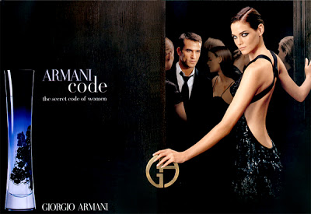
Now your turn…

Mandatory Task for Submission
For this task you must take the Armani Code advert and analyse it. You must analyse at least 5 elements of media language from the poster. Follow the steps below for each paragraph.
Success Criteria
Targets |  | Possible sentence starters
T1 | Identify the element of media language you wish to talk about. Remember this can be anything that creates meaning for the audience. | One elements of media language used in the poster is…  Another element used to communicate meaning is…
T2 | Discuss what meaning it conveys to the audience. How does it make them feel? Try to give various meanings. Think about how we are supposed to feel about the characters in the poster but also the product. What is being said about that? | This makes the audience think…  This makes the audience feel…  This suggests the product is…  This makes you think the product is…
T3 | Why is this appealing to the audience? Remember the idea is to sell the product so why is the example you are discussing going to increase sales and appeal to the target audience. | This appeals to the audience because…  This will help increase sales of the product because…  The target audience will like this because…
T4 | Can you support your ideas within context? Consider competitors posters and conventions of this media type. What does it say about gender roles and expectations in today society | This has been done because…  This suggests…  A similar example is seen in…  This techniques is expected because…

………………………………………………………………………………………………………………………………………………………………………………………………………………………………………………………………………………………………………………………………………………………………………………………………………………………………………………………………………………………………………………………………………………………………………………………………………………………………………………………………………………………………………………………………………………………………………………………………………………………………………………………………………………………………………………………………………………………………………………………………………………………………………………………………………………………………………………………………………………………………………………………………………………………………………………………………………………………………………………………………………………………………………………………………………………………………………………………………………………………………………………………………………………………………………………………………………………………………………………………………………………………………………………………………………………………………………………………………………………………………………………………………………………………………………………………………………………………………………………………………………………………………………………………………………………………………………………………………………………………………………………………………………………………………………………………………………………………………………………………………………………………………………………………………………………………………………………………………………………………………………………………………………………………………………………………………………………………………………………………………………………………………………………………………………………………………………………………………………………………………………………………………………………………………………………………………………………………………………………………………………………………………………………………………………………………………………………………………………………………………………………………………………………………………………………………………………………………………………………………………………………………………………………………………………………………………………………………………………………………………………………………………………………………………………………………………………………………………………………………………………………………………………………………………………………………………………………………………………………………………………………………………………………………………………………………………………………………………………………………………………………………………………………………………………………………………………………………………………………………………………………………………………………………………………………………………………………………………………………………………………………………………………………………………………………………………………………………………………………………………………………………………………………………………………………………………………………………………………………………………………………………………………………………………………………………………………………………………………………………………………………………………………………………………………………………………………………………………………………………………………………………………………………………………………………………………………………………………………………………………………………………………………………………………………………………………………………………………………………………………………………………………………………………………………………………………………………………………………………………………………………………………………………………………………………………………………………………………………………………………………………………………………………………………………………………………………………………………………………………………………………………………………………………………………………………………………………………………………………………………………………………………………………………………………………………………………………………………………………………………………………………………………………………………………………………………………………………………………………………………………………………………………………………………………………………………………………………………………………………………………………………………………………………………………………………………………………………………………………………………………………………………………………………………………………………………………………………………………………………………………………………………………………………………………………………………………………………………………………………………………………………………………………………………………………………………………………………………………………………………………………………………………………………………………………………………………………………………………………………………………………………………………………………………………………………………………………………………………………………………………………………………………………………………………………………………………………………………………………………………………………………………………………………………………………………………………………………………………………………………………………………………………………………………………………………………………………………………………………………………………………………………………………………………………………………………………………………………………………………………………………………………………………………………………………………………………………………………………………………………………………………………………………………………………………………………………………………………………………………………………………………………………………………………………………………………………………………………………………………………………………………………………………………………………………………………………………………………………………………………………………………………………………………………………………………………………………………………………………………………………………………………………………………………………………………………………………………………………………………………………………………………………………………………………………………………………………………………………………………………………………………………………………………………………………………………………………………………………………………………………………………………………………………………………………………………………………………………………………………………………………………………………………………………………………………………………………………………………………………………………………………………………………………………………………………………………………………………………………………………………………………………………………………………………………………………………………………………………………………………………………………………………………………………………………………………………………………………………………………………………………………………………………………………………………………………………………………………………………………………………………………………………………………………………………………………………………………………………………………………………………………………………………………………………………………………………………………………………………………………………………………………………………………………………………………………………………………………………………………………………………………………………………………………………………………………………………………………………………………………………………………………………………………………………………………………………………………………………………………………………………………………………………………………………………………………………………………………………………………………………………………………………………………………………………………………………………………………………………………………………………………………………………………………………………………………………………………………………………………………………………………………………………………………………………………………………………………………………………………………………………………………………………………………………………………………………………………………………………………………………………………………………………………………………………………………………………………………………………………………………………………………………………………………………………………………………………………………………………………………………………………………………………………………………………………………………………………………………………………………………………………………………………………………………………………………………………………………………………………………………………………………………………………………………………………………………………………………………………………………………………………………………………………………………………………………………………………………………………………………………………………………………………………………………………………………………………………………………………………………………………………………………………………………………………………………………………………………………………………………………………………………………………………………………………………………………………………………………………………………………………………………………………………………………………………………………………………………………………………………………………………………………………………………………………………………………………………………………………………………………………………………………………………………………………………………………………………………………………………………………………………………………………………………………………………………………………………………………………………………………………………………………………………………………………………………………………………………………………………………………………………………………………………………………………………………………………………………………………………………………………………………………………………………………………………………………………………………………………………………………………………………………………………………………………………………………………………………………………………………………………………………………………………………………………………………………………………………………………………………………………………………………………………………………………………………………………………………………………………………………………………………………………………………………………………………………………………………………………………………………………………………………………………………………………………………………………………………………………………………………………………………………………………………………………………………………………………………………………………………………………………………………………………………………………………………………………………………………………………………………………………………………………………………………………………………………………………………………………………………………………………………………………………………………………………………………………………………………………………………………………………………………………………………………………………………………………………………………………………………………………………………………………………………………………………………………………………………………………………………………………………………………………………………………………………………………………………………………………………………………………………………………………………………………………………………………………………………………………………………………………………………………………………………………………………………………………………………………………………………………………………………………………………………………………………………………………………………………………………………………………………………………………………………………………………………………………………………………………………………………………………………………………………………………………………………………………………………………………………………………………………………………………………………………………………………………………………………………………………………………………………………………………………………………………………………………………………………………………………………………………………………………………………………………………………………………………………………………………………………………………………………………………………………………………………………………………………………………………………………………………………………………………………………………………………………………………………………………………………………………………………………………………………………………………………………………………………………………………………………………………………………………………………………………………………………………………………………………………………………………………………………………………………………………………………………………………………………………………………………………………………………………………………………………………………………………………………………………………………………………………………………………………………………………………………………………………………………………………………………………………………………………………………………………………………………………………………………………………………………………………………………………………………………………………………………………………………………………………………………………………………………………………………………………………………………………………………………………………………………………………………………………………………………………………………………………………………………………………………………………………………………………………………………………………………………………………………………………………………………………………………………………………………………………………………………………………………………………………………………………………………………………………………………………………………………………………………………………………………………………………………………………………………………………………………………………………………………………………………………………………………………………………………………………………………………………………………………………………………………………………………………………………………………………………………………………………………………………………………………………………………………………………………………………………………………………………………………………………………………………………………………………………………………………………………………………………………………………………………………………………………………………………………………………………………………………………………………………………………………………………………………………………………………………………………………………………………………………………………………………………………………………………………………………………………………………………………………………………………………………………………………………………………………………………………………………………………………………………………………………………………………………………………………………………………………………………………………………………………………………………………………………………………………………………………………………………………………………………………………………………………………………………………………………………………………………………………………………………………………………………………………………………………………………………………………………………Meaning is constructed in many different ways. Our own experiences, upbringing, culture and the lifestyle we have are all factors that contribute to the meaning we attribute to different images, signs and symbols. For example if you see a yellow ‘M’ you may think of MacDonald’s, but if I showed it to someone who has never seen or heard of MacDonald’s they will simply see a yellow ‘M’. What if I showed you a palm tree? You may think of sunny beaches or tropical holidays. People who live in those countries simply see a tree. Look at the images below. Write down the first word that comes in to your head when you see it. Not what it is but what it means to you. In the next box write down as many other words that other people could think of when they see this same image.
 | Your first thought  Example –  Sporty | Other possible meanings  Example –  Reliable, expensive, prestigious, fast, German
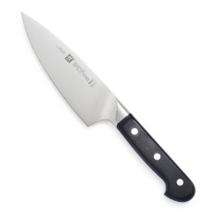





The Colour Green



For more activities and reading on media language follow the links below to further reading or videos. Summarise your findings in the boxes below each link. You may also wish to write down any questions you have about each of the links to help further your understanding.
Cinematography (Pay particular attention to the meaning created when the rule is bent)
https://www.youtube.com/watch?time_continue=6&v=iW0bKUfvH2c&feature=emb_logo

Semiotics (what is the difference between Ferdinand de Saussure and Charles Pierce – further research needed)
https://www.youtube.com/watch?v=p3XvJDxjIpU

Layout and Design (You will be studying magazines so an understanding of how they are set up and used to create meaning is key to your success)
https://www.youtube.com/watch?v=5ewm8H6vwhk

Representation
Representation is perhaps the hardest concept to get to grips with as it deals with the portrayal of people within the media. This is also the content of your unit 1 exam. The portrayal of people within the media is largely determined by the narrative of the text and the end goal of the media producer. Many factors can determine the type of representation used from the producers desire to make large profits, appeal to a specific audience, the time period of the text or its country of origin. Representations cannot be of just people but of events or current issues. The media essentially take existing references and re-package it for the audience or ‘RE-present’ it for them. Many media theorists believe the media is not a reflection of the world but a means in which the world is shaped.
For example if all you saw in the media were people being nice and friendly to each other; then this means people would most likely go out in to the world and be nice and friendly. The media however portrays many different representations from different ages, social groups, cultures, sexualities and more, giving people many different options by which to shape their lives.

Representations can often be controversial in their nature by way of following stereotypes. If I said ‘pirate’ to you… an image like the one to the right is the one that is very likely to pop in to your head. This is because this image is shown in various different forms across many films, TV shows and books over the years.
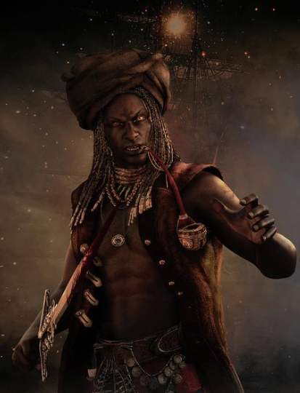

But consider the various images in the media that are less commonly used. This is known as under-representation. Pirates of different genders and ethnicities are rarely used however they are becoming more popular with a demand for ‘wider’ representations. When they are used it is considered a shift from the norm as the media has succeeded in shaping our expectations to the picture above.

Stereotypes are used a lot in media. They are used so the audience can easily recognise the character and their personality traits. They essentially know what to expect from them without having to waste time on back stories or long winded character development. This is often used for subsidiary characters or shows aimed at younger audiences.
More modern times have seen the use of stereotypes to decline, to reduce (misrepresentation). This means if all you ever saw in the media were old people with walking sticks; you were being misled, because not all old people use walking sticks. The trouble is that old people using walking sticks is a stereotype and an easy win for a media producer to convey to an audience that character is old!
Mandatory Task for Submission
Below is a list of character types. Please remember that all these people exist in the real world and in the real world everyone is an individual and does not necessarily conform to a stereotype. For the purposes of media we must be aware of the stereotypes to assess when they are being used and when they are not being used. For each character write down what you may expect to see on screen to portray a stereotype. Write down suggestions and ideas of ways in which that character may be shown subverting (goes against) the stereotype. For each description try to consider how they would behave, talk, dress, where they would live etc.
Character | Conform to stereotype | Subvert stereotype
Blonde Teenager
Black Teenager
Old Man
Lower Class Woman
Upper Class Man
Homosexual man

A French man

For additional help please see the following link
https://examples.yourdictionary.com/stereotype-examples.html
Select one of the stereotypes you have listed and find an example of it being subverted in the media today. This can be a character from a TV show, video game or film, an image in an advert or magazine or an extract from a radio show or music video. Summarise below the way in which they subvert the stereotype and why it is important they do so in the context of your example. Consider what message it gives the audience and how it is trying to break widely held representations in society.
…………………………………………………………………………………………………………………………………………………………………………………………………………………………………………………………………………………………………………………………………………………………………………………………………………………………………………………………………………………………………………………………………………………………………………………………………………………………………………………………………………………………………………………………………………………………………………………………………………………………………………………………………………………………………………………………………………………………………………………………………………………………………………………………………………………………………………………………………………………………………………………………………………………………………………………………………………………………………………………………………………………………………………………………………………………………………………………………………………………………………………………………………………………………………………………………………………………………………………………………………………………………………………………………………………………………………………………………………………………………………………………………………………………………………………………………………………………………………………………………………………………………………………………………………………………………………………………………………………………………………………………………………………………………………………………………………………………………………………………………………………………………………………………………………………………………………………………………………………………………………………………………………………………………………………………………………………………………………………………………………………………………………………………………………………………………………………………………………………………………………………………………………………………………………………………………………………………………………………………………………………………………………………………………………………………………………………………………………………………………………………………………………………………………………………………………………………………………………………………………………………………………………………………………………………………………………………………………………………………………………………………………………………………………………………………………………………………………………………………………………………………………………………………………………………………………………
For more activities and reading on media representation follow the links below to further reading or videos. Summarise your findings in the boxes below each link. You may also wish to write down any questions you have about each of the links to help further your understanding.
Changing the way we are (this is concept looks at the way the media shapes our behaviours. Seeing certain undesirable behaviours may make us act this way. We?)
https://www.youtube.com/watch?v=TBy1-Fkiqk0

David Gauntlett (consider how the media doesn’t just shape the way we see others but how we construct our own identity)
https://www.youtube.com/watch?v=tTRk3Y6BnqA

Media Representation – If you see it, you can be it (a frank conversation from about media representation. Write down key ideas, examples or discussion points from this video)
https://www.youtube.com/watch?v=wGuueqUy2Cc

Media Production
Media production forms a great deal of your course over the next two years. When looking at methods of production it is important to consider how production styles and techniques change with genre. Genre in the media is an excellent tool to appeal to an audience. Some people like action some people like horror. To appeal to those people you simply need to follow the conventions of that genre. Conventions are elements of the film that repeat across the genre. For example in an action film you expect to see explosions. It wouldn’t be an action film without an explosion. This means a convention of an action film is an explosion. Other examples for this genre may be a car chase, fighting, guns, villains etc. You would expect to see these features in a film if it was considered an action film. As an audience member you would be disappointed if they were not there.
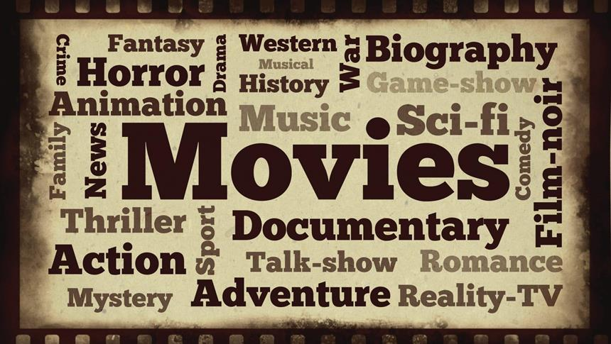

But doesn’t this get boring? Having every action film have the same content? Well…no? Steve Neale says that ‘genres are instances of repetition and difference’. The ‘difference’ is looking at ways of making those repeated elements of the genre varied between products to keep the audience engaged. A good example would be James Bond movies and the Fast and Furious movies. Both sets of movies have car chases in them but both are very different.
Codes and Conventions
Genre Specific Codes and Conventions | Difference
In this column write down the codes and conventions of the different genres. What you would expect to see in order to identify the genre (meeting audience expectations) | In this column you must give examples of how different films try to adapt and tweak these codes of repetition in order to make them unique and engaging for the audience
Sci Fi
- Space ships  - Aliens  - Off World Locations (New Planets, Galaxies, In Space)  - Futuristic technology  - Futuristic Weapons  - Utopian/Dystopian Realities  - Super Human Strength/Abilities | Star Wars  - X Wing, Millennium Flacon, Death Star  - Wookie, The Huts  - Tatooine, Jaku  - Hyper Drive  - Lightsabers, Laser Pistols  - Jedi Vs. The Republic or The rebels Vs. The empire  - The Force, The Dark Side  Star Wars Specific Codes  - Opening Titles  - Wipe Transitions
Action
Comedy
Romance
Crime Thriller
Horror
Fantasy
War
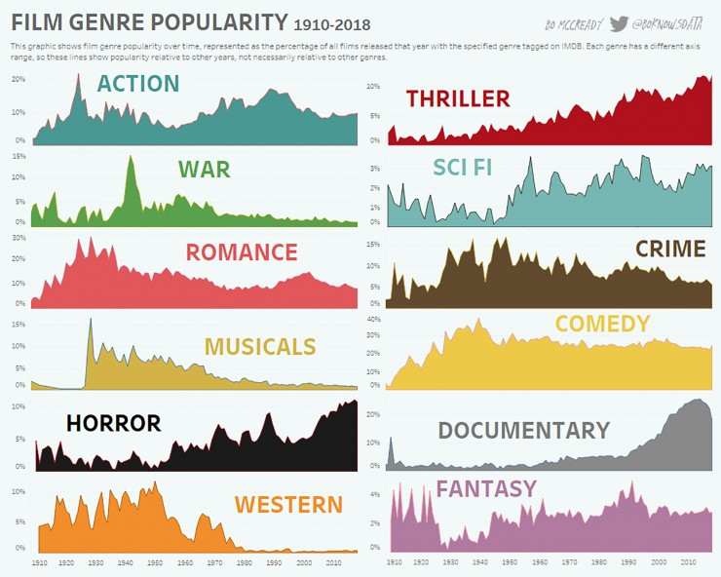

Media production must always start with an idea before you even get the camera out. How are you going to piece together a story? What is that story going to look like and how will it end. What journey will the audience be taken on and how will a director get across their signature stlye or genre specific conventions! All these must be considered as part of the planning before production takes place.
Mandatory Task – Film Production techniques
There are four key techniques that are in play when producing a piece of film. Cinematography which tackles everything to do with camera work. Sound which looks at sound that has been added in during and post production, editing and mise en-scene which looks at everything in the scene itself. Conduct some research in to some of the key terms on the next page to help you provide an analysis of a video clip I have selected.
Cinematography | Editing
Camera Angles  Birdseye View, High Angle, Low Angle, Wormseye View  Camera Shots  Extreme Close Up, Close Up, Medium Close Up, Mid Shot, Medium Long Shot, Extreme Long Shot  Camera Movements  Hand Held, Pan, Tilt, Crane, Ariel, Track | Cut  Shot reverse shot  Cross cut  Eyeline match  Montage  Match Cut  180 degree rule
Sound | Mise-En-Scene
Diegetic sound  Non diegetic sound  Parallel sound  Contrapuntal sound  Ambient Sound | Setting/Location  Props  Performance  Costume/Make up  Positiopning  Colour  Lighting

Mandatory Task – Scene Analysis
Look at the clip in the link below. Using the knowledge you have gained from your research can you provide an analysis of some of the techniques used in the clip. Try to aim for 5 examples.
For each example you must follow the following success criteria…
Success Criteria
Targets |  | Possible sentence starters
T1 | Identify the element of media language you wish to talk about. Remember this can be anything that creates meaning for the audience. | One elements of media language used in the poster is…  Another element used to communicate meaning is…
T2 | Discuss what meaning it conveys to the audience. How does it make them feel? Try to give various meanings. Think about how we are supposed to feel about the characters in the poster but also the product. What is being said about that? | This makes the audience think…  This makes the audience feel…  This suggests the product is…  This makes you think the product is…
T3 | Why is this appealing to the audience? Remember the idea is to sell the product so why is the example you are discussing going to increase sales and appeal to the target audience. | This appeals to the audience because…  This will help increase sales of the product because…  The target audience will like this because…

What Lies Beneath - https://www.youtube.com/watch?v=Jjfj3SkBkpg&list=PLZbXA4lyCtqoc48K1nLbl-_iY9E0PIhzf&index=7&t=0s
In lessons we use a slightly longer version of this clip but you will be able to analyse a number of techniques well in this clip. It is best that you haven’t seen the film so you take the techniques at their core value and explain the impact on the audience form what you can infer as opposed to what you know in context.
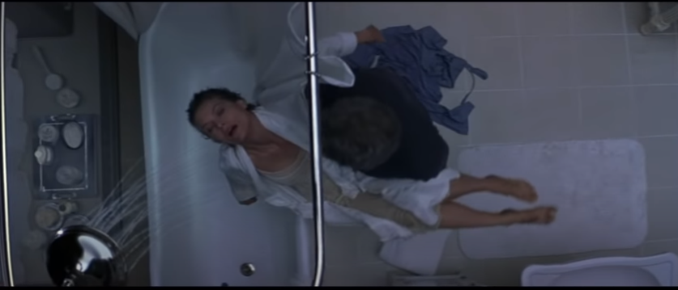
This link https://www.churchdownmediahub2.com/film-form.html couple with your own research will help.
……………………………………………………………………………………………………………………………………………………………………………………………………………………………………………………………………………………………………………………………………………………………………………………………………………………………………………………………………………………………………………………………………………………………………………………………………………………………………………………………………………………………………………………………………………………………………………………………………………………………………………………………………………………………………………………………………………………………………………………………………………………………………………………………………………………………………………………………………………………………………………………………………………………………………………………………………………………………………………………………………………………………………………………………………………………………………………………………………………………………………………………………………………………………………………………………………………………………………………………………………………………………………………………………………………………………………………………………………………………………………………………………………………………………………………………………………………………………………………………………………………………………………………………………………………………………………………………………………………………………………………………………………………………………………………………………………………………………………………………………………………………………………………………………………………………………………………………………………………………………………………………………………………………………………………………………………………………………………………………………………………………………………………………………………………………………………………………………………………………………………………………………………………………………………………………………………………………………………………………………………………………………………………………………………………………………………………………………………………………………………………………………………………………………………………………………………………………………………………………………………………………………………………………………………………………………………………………………………………………………………………………………………………………………………………………………………………………………………………………………………………………………………………………………………………………………………………………………………………………………………………………………………………………………………………………………………………………………………………………………………………………………………………………………………………………………………………………………………………………………………………………………………………………………………………………………………………………………………………………………………………………………………………………………………………………………………………………………………………………………………………………………………………………………………………………………………………………………………………………………………………………………………………………………………………………………………………………………………………………………………………………………………………………………………………………………………………………………………………………………………………………………………………………………………………………………………………………………………………………………………………………………………………………………………………………………………………………………………………………………………………………………………………………………………………………………………………………………………………………………………………………………………………………………………………………………………………………………………………………………………………………………………………………………………………………………………………………………………………………………………………………………………………………………………………………………………………………………………………………………………………………………………………………………………………………………………………………………………………………………………………………………………………………………………………………………………………………………………………………………………………………………………………………………………………………………………………………………………………………………………………………………………………………………………………………………………………………………………………………………………………………………………………………………………………………………………………………………………………………………………………………………………………………………………………………………………………………………………………………………………………………………………………………………………………………………………………………………………………………………………………………………………………………………………………………………………………………………………………………………………………………………………………………………………………………………………………………………………………………………………………………………………………………………………………………………………………………………………………………………………………………………………………………………………………………………………………………………………………………………………………………………………………………………………………………………………………………………………………………………………………………………………………………………………………………………………………………………………………………………………………………………………………………………………………………………………………………………………………………………………………………………………………………………………………………………………………………………………………………………………………………………………………………………………………………………………………………………………………………………………………………………………………………………………………………………………………………………………………………………………………………………………………………………………………………………………………………………………………………………………………………………………………………………………………………………………………………………………………………………………………………………………………………………………………………………………………………………………………………………………………………………………………………………………………………………………………………………………………………………………………………………………………………………………………………………………………………………………………………………………………………………………………………………………………………………………………………………………………………………………………………………………………………………………………………………………………………………………………………………………………………………………………………………………………………………………………………………………………………………………………………………………………………………………………………………………………………………………………………………………………………………………………………………………………………………………………………………………………………………………………………………………………………………………………………………………………………………………………………………………………………………………………………………………………………………………………………………………………………………………………………………………………………………………………………………………………………………………………………………………………………………………………………………………………………………………………………………………………………………………………………………………………………………………………………………………………………………………………………………………………………………………………………………………………………………………………………………………………………………………………………………………………………………………………………………………………………………………………………………………………………………………………………………………………………………………………………………………………………………………………………………………………………………………………………………………………………………………………………………………………………………………………………………………………………………………………………………………………………………………………………………………………………………………………………………………………………………………………………………………………………………………………………………………………………………………………………………………………………………………………………………………………………………………………………………………………………………………………………………………………………………………………………………………………………………………………………………………………………………………………………………………………………………………………………………………………………………………………………………………………………………………………………………………………………………………………………………………………………………………………………………………………………………………………………………………………………………………………………………………………………………………………………………………………………………………………………………………………………………………………………………………………………………………………………………………………………………………………………………………………………………………………………………………………………………………………………………………………………………………………………………………………………………………………………………………………………………………………………………………………………………………………………………………………………………………………………………………………………………………………………………………………………………………………………………………………………………………………………………………………………………………………………………………………………………………………………………………………………………………………………………………………………………………………………………………………………………………………………………………………………………………………………………………………………………………………………………………………………………………………………………………………………………………………………………………………………………………………………………………………………………………………………………………………………………………………………………………………………………………………………………………………………………………………………………………………………………………………………………………………………………………………………………………………………………………………………………………………………………………………………………………………………………………………………………………………………………………………………………………………………………………………………………………………………………………………………………………………………………………………………………………………………………………………………………………………………………………………………………………………………………………………………………………………………………………………………………………………………………………………………………………………………………………………………………………………………………………………………………………………………………………………………………………………………………………………………………………………………………………………………………………………………………………………………………………………………………………………………………………………………………………………………………………………………………………………………………………………………………………………………………………………………………………………………………………………………………………………………………………………………………………………………………………………………………………………………………………………………………………………………………………………………………………………………………………………………………………………………………………………………………………………………………………………………………………………………………………………………………………………………………………………………………………………………………………………………………………………………………………………………………………………………………………………………………………………………………………………………………………………………………………………………………………………………………………………………………………………………………………………………………………………………………………………………………………………………………………………………………………………………………………………………………………………………………………………………………………………………………………………………………………………………………………………………………………………………………………………………………………………………………………………………………………………………………………………………………………………………………………………………………………………………………………………………………………………………………………………………………………………………………………………………………………………………………………………………………………………………………………………………………………………………………………………………………………………………………………………………………………………………………………………………………………………………………………………………………………………………………………………………………………………………………………………………………………………………………………………………………………………………………………………………………………………………………………………………………………………………………………………………………………………………………………………………………………………………………………………………………………………………………………………………………………………………………………………………………………………………………………………………………………………………………………………………………………………………………………………………………………………………………………………………………………………………………………………………………………………………………………………………………………………………………………………………………………………………………………………………………………………………………………………………………………………………………………………………………………………………………………………………………………………………………………………………………………………………………………………………………………………………………………………………………………………………………………………………………………………………………………………………………………………………………………………………………………………………………………………………………………………………………………………………………………………………………………………………………………………………………………………………………………………………………………………………………………………………………………………………………………………………………………………………………………………………………………………………………………………………………………………………………………………………………………………………………………………………………
For more activities and reading on media production follow the links below to further reading or videos. Summarise your findings in the boxes below each link. You may also wish to write down any questions you have about each of the links to help further your understanding.
The film industry today (watch this TED talk to get an insight in to the companies behind film production)
https://www.youtube.com/watch?v=QvrnHLOXABc

Financing (how to find financing for your film – make sure you know the difference between production and distribution before watching this)
https://www.youtube.com/watch?v=uwLph9VNzjM

How does a film get made – (first in a series of videos looking at the work that goes in to making a film all with the idea of making a big profit upon its release)
https://www.youtube.com/watch?v=TARsoxST0tQ

Contextual Development – Advertisement
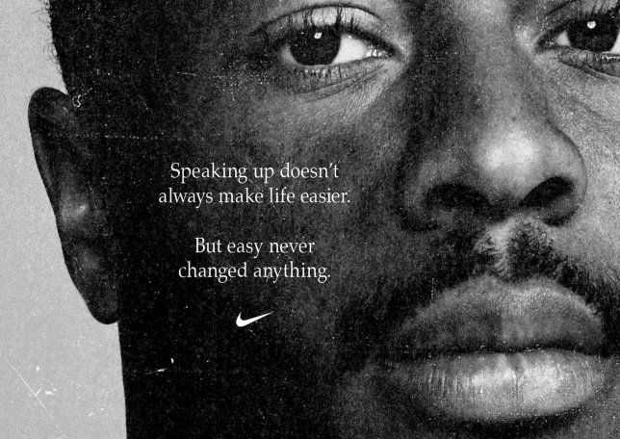
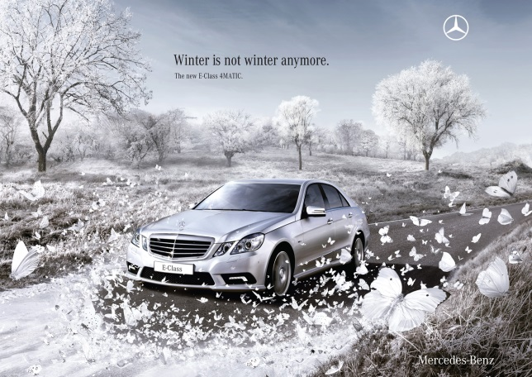
Advertisement is a key area of the media that heavily relies on the use of media language to target its audience. From the knowledge you have gained so far consider the two adverts below. Can you analyse them and discuss the techniques used to create the messages within them. Remember everything is there for a reason.

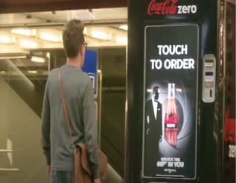
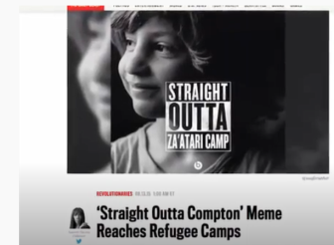
Advertisement is much more than posters and TV ads. With the development of technology advertisement has had to become clever and draw the audience in. Watch the viral ad campaigns bellow for Straight Outta Compton and James Bond. Can you think why they were successful and find any other examples of this type of campaign.
https://www.youtube.com/watch?v=m2XQgCHX2TI
https://www.youtube.com/watch?v=_pCRfiQCSbU

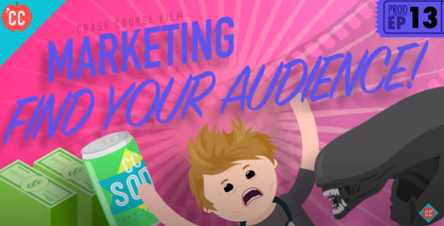
Film promotion takes up a huge amount of money from the films budget often being at least 50% of the production budget. That means if a film cost $100 million dollars to make, they would probably spend at least $50 million on promoting and advertising the film. Watch the video below to see all the different ways in which a film is promoted.

https://www.youtube.com/watch?v=04C3B1Ztwf0

Can you find out the different ways the Lego movie was promoted? This forms part of your first exam!
Contextual Development – Pitching
Pitching a film is an important skill to do in the film industry. It can be the difference between getting the green light or not. Some film will cast actors and directors before the green light to include them in their pitch to make the film seem more appealing.
Part of your course will be creating a film production of your own. Use the space below to help you come up with some ideas. Use the first box to brain storm genre, storyline, props, props, location, plot and narrative devices and more. Use the second box to write out a pitch explaining your final idea as if you were trying to convince them it was a good film to make. Remember conventions and audience expectations for this.

https://www.youtube.com/watch?v=YOzyYxn8siA – the greatest showman only got greenlit after a full cast performance in front of the production and distribution companies. This is a pitch on a whole new level!
Contextual Development - Video Killed the Radio Star
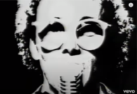
In the words of the Buggles song… ‘Video killed the radio star’. Essentially what we are saying is when something bigger and better comes along something else has to go and that is true of the media and technology. Cartridge based games consoles, mini disc player, VHS? No didn’t think so? Even popular media platforms today such as blu-rays are suffering due to the introduction of streaming sites and VOD. For this section of contextual development I want to give you the oppurtunity to consider 3 pieces of failed/discontinued technology and consider why they no longer exist as well as examples of developing technology and discuss why they are so popular and make a difference to the way we consume media. Use the two below for each section plus one of your choice for each section.
Discontinued technology
For each one, research the product and its background. Find details on its successes and failures and ultimate why it no longer exists. Did it get replaced or did the consumer simply not like it?
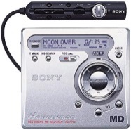
Mini Disc Player

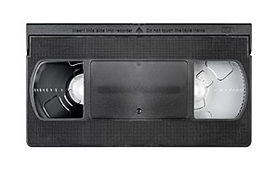
VHS

Current/New Technology
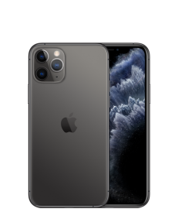
For each one, research the product and its background. Find details on its successes using facts and figures such as sales and users. What impact is it having on its competitors and how does it affect the way we consume the media?
Smart Phone


Streaming Services

Contextual Development – Wider Reading
As a media student is essential that you develop your independent learning skills and carry out wider reading around your subject. Here is a list of books and websites which will help you prepare for the theoretical aspect of the Media Studies course
Books
Media, Gender and Identity by David Gauntlett
Feminism is for Everybody by bell hooks
Feminist Media Studies by Liesbet van Zoonen
Gender Trouble by Judith Butler
After Empire by Paul Gilroy
Media Regulation by Lunt and Livingstone
Here Comes Everybody by Clay Shirky
Cognitive Surplus: Creativity and Generosity in a Connected Age by Clay Shirky
Representation: Cultural Representations and Signifying Practices Edited by Stuart Hall
Power without Responsibility: Press, Broadcasting and the Internet in Britain by James Curran
The Cultural Industries by David Hesmondhalgh
Convergence Culture: Where Old and New Media Collide by Henry Jenkins
Websites
The Media Guardian: https://www.theguardian.com/uk/media
EMC’s Media Magazine: https://www.englishandmedia.co.uk/media-magazine (well worth subscribing to – we have hard copies delivered to school available to loan from MD1)
British Film Institute: http://www.bfi.org.uk/
BTEC Qualification Page : https://qualifications.pearson.com/en/qualifications/btec-nationals/creative-digital-media-production-2016.html
Churchdown Media Hub: https://www.churchdownmediahub2.com/
(Password – churchdownmediahub)
Contextual Development – Wider Watching
It seems mad people would opt to do a course without a keen interest in the subject. Especially media! I love films! It would greatly help if you did too…or music or TV or anything related to the media. Your own experiences and engagements with the media will feed in to the topics we cover and help you to apply theories and course content in different contexts.
Many people ask me to recommend films to watch that will help them in the course. Here is a list of films I enjoy or find that they challenge ideology or conventions in some way. Watch any of these for some good discussions to be had in the future. I always have more if you plough through these. Happy watching. (Age restrictions may apply)
- Fight Club
- Shutter Island
- Batman the Dark Knight
- The Joker
- Looper
- Reservoir dogs
- Kingdom of Heaven
- Eternal Sunshine of the Spotless Mind
- 23
- The Truman Show
- Stranger Than Fiction
- Momento
- Inception
- Pulp Fiction
- Forrest Gump
- The Matrix
- Seven
- Saving Private Ryan
- The Departed
- The Prestige
- Whiplash
- Sixth Sense
- Back to the Future
- Indiana Jones – The Last Crusade
- Minority Report

Contextual Development – Media Theorists
During the Media Studies course you will encounter many media theorists that have studied various areas of the media. In order to give you a head start you should research as many of these theorists as possible and produce a short paragraph on each that outlines their key theories linked with each of the concepts below:
Media Language
Semiology –Roland Barthes
Narratology –Todorov
Genre Theory –Steve Neale
Structuralism –Claude Levi-Strauss
Postmodernism –Baudrillard
Media Representations
Theories of Representation –Stuart Hall
Theories of Identity –David Gauntlett
Feminist Theory –Van Zoonen
Media Audiences
Media Effects –Bandura
Cultivation Theory –George Gerbner
Fandom –Henry Jenkins
‘End of Audience’ Theories –Clay Shirky
Media Industries
Power and Media Industries –James Curran and Jean Seaton
Regulation –Livingstone and Lunt
Cultural Industries –Hesmondhalgh

