
Transition Pack
For
A – Level Media

Mandatory Tasks – Submit to ATE@churchdownschool.com
Task | Page No. | Completed (tick) | Score (if applicable)
Textual Analysis – Armani Code | 5 - 9
Stereotypes | 13 - 14
Internet Regulation – Yes or No? | 24 - 29
Video Killed the Radio Star | 33

Optional Tasks
Task | What did you read, see or do?
Book recommendations
Movie Recommendations
Online video/article recommendations

Welcome to A Level Media
Media studies is a vital part of society. Media is all around us and the media is becoming more prevalent in the work place so I cannot stress how important the content of this subject is. Whatever job or career you go in to in the future it will have some involvement with the media and we must consider how the media operate in order to understand its power in the world we live in.
What is the media? Day one of year 12 I will ask you this question. No doubt throughout this booklet you will have a good sense of what it is but before you begin please write down your thoughts or a definition in the space below. We will go one step further to consider if the media is a good or a bad thing? Try to do some research to establish how you feel about the media and its use in current society. Think of it from a producer’s point of view, and a consumers.
What is the media?

Media Studies is assessed over three key elements. Two exams and one practical. We stress the emphasis on the examined units as they are worth 70% of the course. They will test your knowledge of the media theoretical framework across a series of ‘set products’. These set products must be known inside out to succeed and it is worth watching, researching or engaging with these products now so you are familiar with them when we come to study them. Use the table below to see the set products and begin your research into each one. This can be as simple as watching, listening or reading to familiarise yourself with the content. Further details of all the set products and the kind work expected of you throughout the course is available on the media hub. Just select subjects – AS Media. www.churchdownmediahub2.com password – churchdownmediahub
Component 1
Advertising | Tide Print Advert (1950s)
 | Kiss of the Vampire Poster (1960s)
 | Superhuman (2000s)
Film Promotion | Black Panther/I Daniel Blake
Music Video | TurnTables Janelle Monae/ Riptide Vance Joy
Radio | Womens Hour
News | The Daily Mirror/The Times
Video Games | Assassins Creed Franchise
Component 2
Television | Peaky Blinders/The Bridge
Magazines | Woman Magazine/Adbusters
Online Media | Zoella/Attitude
Resources
At Churchdown we are product to be able to offer you a fully integrated and accessible on line learning platform in the form of ‘the churchdown media hub’. This should be accessed daily as a media student completing independent work, pre-reading and accessing the resources for revision and assessments. Each page is loaded with key information on each of the set products, sample answers, models, videos and opportunities to develop your knowledge beyond the set curriculum.
www.churchdownmediahub.com
password – churchdownmediahub
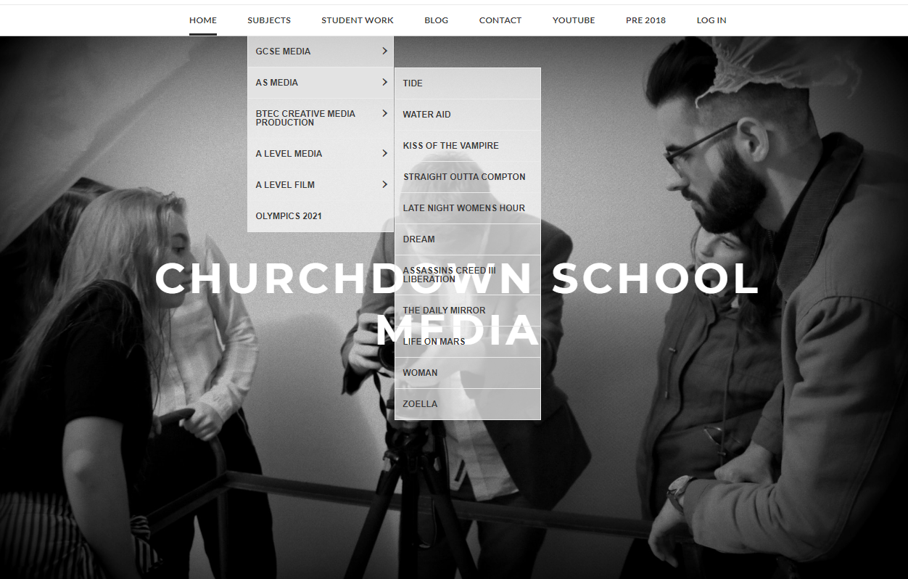
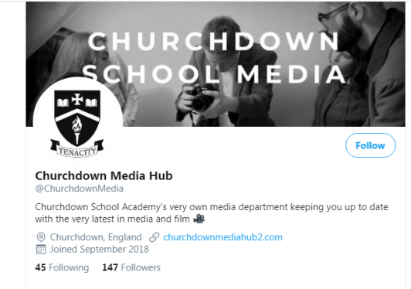
Our twitter account is also extremely popular and useful for communication with teachers, access to wider resources and to further deepen your knowledge within the subject. We strongly recommend that as a sixth form student in media you follow this account and engage with the content. Feel free to share anything you feel may be of interest to the media cohort at Churchdown School.

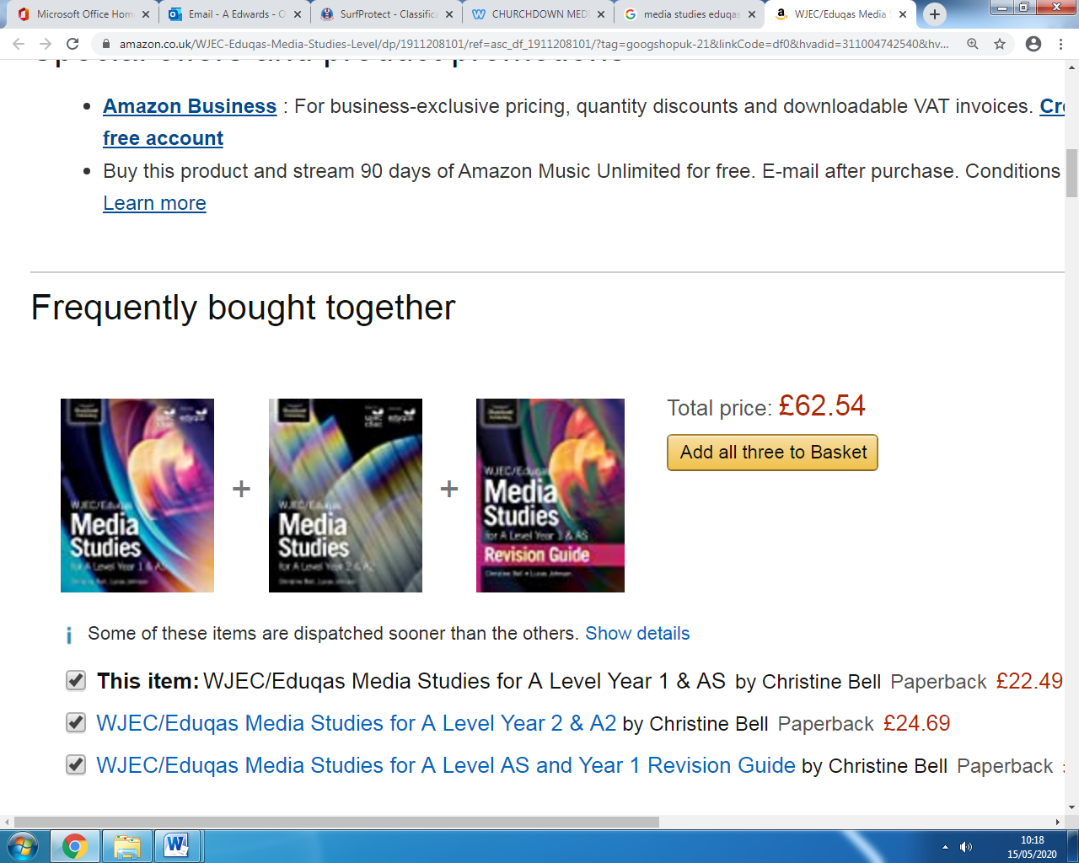
As part of the course you are also recommended to get the following text books to support your learning. They are broken down in to year 1, year 2 and a revision guide. They are used in lessons and we do have limited copies for students to use in school.
They are available from a number of online retailers. Simply search ‘Media Studies A Level text book eduqas)
Media Language
Media language is the key starting point for studying media studies. It is the way the media communicates with the audience. This can of course be verbal but also non-verbal in a large number of cases. Facial expressions, colour, clothing, lighting, camera angles, body language all communicate meaning and it is up to us studying media to try and understand the meaning being communicated by what we see. Before we look at some examples take a look at some of the key words in this area of the theoretical framework.
Research the meaning of each word and write the definition in the space provided.
Denotation
Connotation
Semiotics
Symbolic Codes
Preferred Reading
Polysemy
Encoding
Decoding
Anchorage
Target Audience

There is one big issue with the use of media language and it is the same as the spoken language. Not all things mean the same to different people. For example; the word chicken may make you think of the bird which you see on a farm laying eggs but the word can also be used to describe someone who is scared. So if a producer of the media chose to use the word chicken they would need to be careful on the context in which it was used in order to generate the correct response from the audience.
Textual Analysis Task
Let’s take a look at this fiat 500 advert. Follow the steps to analyse this text.
1 – Identify the elements of media language used. (Colours, text, model – body language, clothes)
2 – For each one consider what they are saying about the car and the people they want to buy it
3 – Piece together all these elements to create a cohesive message intended for the audience by the media producers.
Remember this… the point of the advert is to sell the car so the message is intended for its target audience. If you don’t get the message you may simply not be the target audience but we must try to analyse the text by breaking down the use of media language.

Text – Compares car to clothing or accessory and this is a fun car to have. Implies you are not boring if you drive this car.

Layout – Finer details about the car in smaller font but laid out similar to that of a fashion magazine to continue theme of fashion and style

Model – Position and clothing again reflect that of a model seen in a fashion magazine further supporting the cars appeal. Female could suggest target audience

Text – further links to clothing and fashion to suggest the car is in style.

Colour – bold vibrant colours to draw attention to the ad but also to support the notion of fun and quirky. Suggest younger target audience

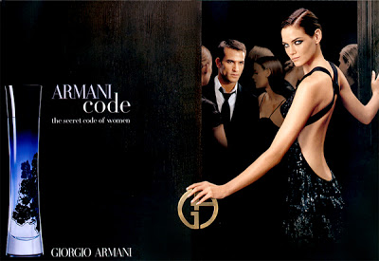
Now your turn…

Mandatory Task for Submission
For this task you must take the Armani Code advert and analyse it. You must analyse at least 5 elements of media language from the poster. Follow the steps below for each paragraph.
Success Criteria
Targets |  | Possible sentence starters
T1 | Identify the element of media language you wish to talk about. Remember this can be anything that creates meaning for the audience. | One elements of media language used in the poster is…  Another element used to communicate meaning is…
T2 | Discuss what meaning it conveys to the audience. How does it make them feel? Try to give various meanings. Think about how we are supposed to feel about the characters in the poster but also the product. What is being said about that? | This makes the audience think…  This makes the audience feel…  This suggests the product is…  This makes you think the product is…
T3 | Why is this appealing to the audience? Remember the idea is to sell the product so why is the example you are discussing going to increase sales and appeal to the target audience. | This appeals to the audience because…  This will help increase sales of the product because…  The target audience will like this because…
T4 | Can you support your ideas within context? Consider competitors posters and conventions of this media type. What does it say about gender roles and expectations in today society | This has been done because…  This suggests…  A similar example is seen in…  This techniques is expected because…

………………………………………………………………………………………………………………………………………………………………………………………………………………………………………………………………………………………………………………………………………………………………………………………………………………………………………………………………………………………………………………………………………………………………………………………………………………………………………………………………………………………………………………………………………………………………………………………………………………………………………………………………………………………………………………………………………………………………………………………………………………………………………………………………………………………………………………………………………………………………………………………………………………………………………………………………………………………………………………………………………………………………………………………………………………………………………………………………………………………………………………………………………………………………………………………………………………………………………………………………………………………………………………………………………………………………………………………………………………………………………………………………………………………………………………………………………………………………………………………………………………………………………………………………………………………………………………………………………………………………………………………………………………………………………………………………………………………………………………………………………………………………………………………………………………………………………………………………………………………………………………………………………………………………………………………………………………………………………………………………………………………………………………………………………………………………………………………………………………………………………………………………………………………………………………………………………………………………………………………………………………………………………………………………………………………………………………………………………………………………………………………………………………………………………………………………………………………………………………………………………………………………………………………………………………………………………………………………………………………………………………………………………………………………………………………………………………………………………………………………………………………………………………………………………………………………………………………………………………………………………………………………………………………………………………………………………………………………………………………………………………………………………………………………………………………………………………………………………………………………………………………………………………………………………………………………………………………………………………………………………………………………………………………………………………………………………………………………………………………………………………………………………………………………………………………………………………………………………………………………………………………………………………………………………………………………………………………………………………………………………………………………………………………………………………………………………………………………………………………………………………………………………………………………………………………………………………………………………………………………………………………………………………………………………………………………………………………………………………………………………………………………………………………………………………………………………………………………………………………………………………………………………………………………………………………………………………………………………………………………………………………………………………………………………………………………………………………………………………………………………………………………………………………………………………………………………………………………………………………………………………………………………………………………………………………………………………………………………………………………………………………………………………………………………………………………………………………………………………………………………………………………………………………………………………………………………………………………………………………………………………………………………………………………………………………………………………………………………………………………………………………………………………………………………………………………………………………………………………………………………………………………………………………………………………………………………………………………………………………………………………………………………………………………………………………………………………………………………………………………………………………………………………………………………………………………………………………………………………………………………………………………………………………………………………………………………………………………………………………………………………………………………………………………………………………………………………………………………………………………………………………………………………………………………………………………………………………………………………………………………………………………………………………………………………………………………………………………………………………………………………………………………………………………………………………………………………………………………………………………………………………………………………………………………………………………………………………………………………………………………………………………………………………………………………………………………………………………………………………………………………………………………………………………………………………………………………………………………………………………………………………………………………………………………………………………………………………………………………………………………………………………………………………………………………………………………………………………………………………………………………………………………………………………………………………………………………………………………………………………………………………………………………………………………………………………………………………………………………………………………………………………………………………………………………………………………………………………………………………………………………………………………………………………………………………………………………………………………………………………………………………………………………………………………………………………………………………………………………………………………………………………………………………………………………………………………………………………………………………………………………………………………………………………………………………………………………………………………………………………………………………………………………………………………………………………………………………………………………………………………………………………………………………………………………………………………………………………………………………………………………………………………………………………………………………………………………………………………………………………………………………………………………………………………………………………………………………………………………………………………………………………………………………………………………………………………………………………………………………………………………………………………………………………………………………………………………………………………………………………………………………………………………………………………………………………………………………………………………………………………………………………………………………………………………………………………………………………………………………………………………………………………………………………………………………………………………………………………………………………………………………………………………………………………………………………………………………………………………………………………………………………………………………………………………………………………………………………………………………………………………………………………………………………………………………………………………………………………………………………………………………………………………………………………………………………………………………………………………………………………………………………………………………………………………………………………………………………………………………………………………………………………………………………………………………………………………………………………………………………………………………………………………………………………………………………………………………………………………………………………………………………………………………………………………………………………………………………………………………………………………………………………………………………………………………………………………………………………………………………………………………………………………………………………………………………………………………………………………………………………………………………………………………………………………………………………………………………………………………………………………………………………………………………………………………………………………………………………………………………………………………………………………………………………………………………………………………………………………………………………………………………………………………………………………………………………………………………………………………………………………………………………………………………………………………………………………………………………………………………………………………………………………………………………………………………………………………………………………………………………………………………………………………………………………………………………………………………………………………………………………………………………………………………………………………………………………………………………………………………………………………………………………………………………………………………………………………………………………………………………………………………………………………………………………………………………………………………………………………………………………………………………………………………………………………………………………………………………………………………………………………………………………………………………………………………………………………………………………………………………………………………………………………………………………………………………………………………………………………………………………………………………………………………………………………………………………………………………………………………………………………………………………………………………………………………………………………………………………………………………………………………………………………………………………………………………………………………………………………………………………………………………………………………………………………………………………………………………………………………………………………………………………………………………………………………………………………………………………………………………………………………………………………………………………………………………………………………………………………………………………………………………………………………………………………………………………………………………………………………………………………………………………………………………………………………………………………………………………………………………………………………………………………………………………………………………………………………………………………………………………………………………………………………………………………………………………………………………………………………………………………………………………………………………………………………………………………………………………………………………………………………………………………………………………………………………………………………………………………………………………………………………………………………………………………………………………………………………………………………………………………………………………………………………………………………………………………………………………………………………………………………………………………………………………………………………………………………………………………………………………………………………………………………………………………………………………………………………………………………………………………………………………………………………………………………………………………………………………………………………………………………………………………………………………………………………………………………………………………………………………………………………………………………………………………………………………………………………………………………………………………………………………………………………………………………………………………………………………………………………………………………………………………………………………………………………………………………………………………………………………………………………………………………………………………………………………………………………………………………………………………………………………………………………………………………………………………………………………………………………………………………………………………………………………………………………………………………………………………………………………………………………………………………………………………………………………………………………………………………………………………………………………………………………………………………………………………………………………………………………………………………………………………………………………………………………………………………………………………………………………………………………………………………………………………………………………………………………………………………………………………………………………………………………………………………………………………………………………………………………………………………………………………………………………………………………………………………………………………………………………………………………………………………………………………………………………………………………………………………………………………………………………………………………………………………………………………………………………………………………………………………………………………………………………………………………………………………………………………………………………………………………………………………………………………………………………………………………………………………………………………………………………………………………………………………………………………………………………………………………………………………………………………………………………………………………………………………………………………………………………………………………………………………………………………………………………………………………………………………………………………………………………………………………………………………………………………………………………………………………………………………………………………………………………………………………………………………………………………………………………………………………………………………………………………………………………………………………………………………………………………………………………………………………………………………………………………………………………………………………………………………………………………………………………………………………………………………………………………………………………………………………………………………………………………………………………Meaning is constructed in many different ways. Our own experiences, upbringing, culture and the lifestyle we have are all factors that contribute to the meaning we attribute to different images, signs and symbols. For example if you see a yellow ‘M’ you may think of MacDonald’s, but if I showed it to someone who has never seen or heard of MacDonald’s they will simply see a yellow ‘M’. What if I showed you a palm tree? You may think of sunny beaches or tropical holidays. People who live in those countries simply see a tree. Look at the images below. Write down the first word that comes in to your head when you see it. Not what it is but what it means to you. In the next box write down as many other words that other people could think of when they see this same image.
 | Your first thought  Example –  Sporty | Other possible meanings  Example –  Reliable, expensive, prestigious, fast, German
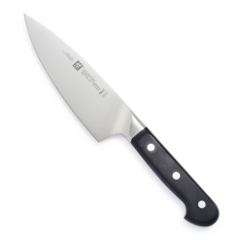





The Colour Green

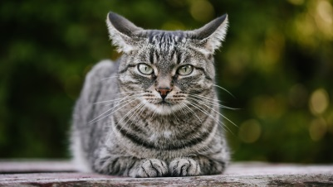

For more activities and reading on media language follow the links below to further reading or videos. Summarise your findings in the boxes below each link. You may also wish to write down any questions you have about each of the links to help further your understanding.
Cinematography (Pay particular attention to the meaning created when the rule is bent)
https://www.youtube.com/watch?time_continue=6&v=iW0bKUfvH2c&feature=emb_logo

Semiotics (what is the difference between Ferdinand de Saussure and Charles Pierce – further research needed)
https://www.youtube.com/watch?v=p3XvJDxjIpU

Layout and Design (You will be studying magazines so an understanding of how they are set up and used to create meaning is key to your success)
https://www.youtube.com/watch?v=5ewm8H6vwhk

Representation
Representation is perhaps the hardest concept to get to grips with as it deals with the portrayal of people within the media. The portrayal of people within the media is largely determined by the narrative of the text and the end goal of the media producer. Many factors can determine the type of representation used from the producers desire to make large profits, appeal to a specific audience, the time period of the text or its country of origin. Representations cannot be of just people but of events or current issues. The media essentially take existing references and re-package it for the audience or ‘RE-present’ it for them. Many media theorists believe the media is not a reflection of the world but a means in which the world is shaped.
For example if all you saw in the media were people being nice and friendly to each other; then this means people would most likely go out in to the world and be nice and friendly. The media however portrays many different representations from different ages, social groups, cultures, sexualities and more, giving people many different options by which to shape their lives.
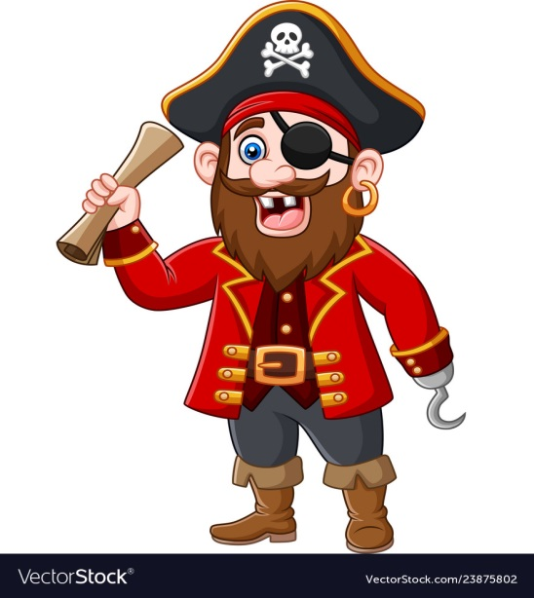
Representations can often be controversial in their nature by way of following stereotypes. If I said ‘pirate’ to you… an image like the one to the right is the one that is very likely to pop in to your head. This is because this image is shown in various different forms across many films, TV shows and books over the years.
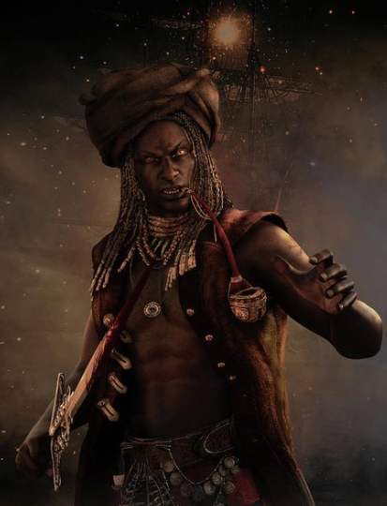

But consider the various images in the media that are less commonly used. This is known as under-representation. Pirates of different genders and ethnicities are rarely used however they are becoming more popular with a demand for ‘wider’ representations. When they are used it is considered a shift from the norm as the media has succeeded in shaping our expectations to the picture above.

Stereotypes are used a lot in media. They are used so the audience can easily recognise the character and their personality traits. They essentially know what to expect from them without having to waste time on back stories or long winded character development. This is often used for subsidiary characters or shows aimed at younger audiences.
More modern times have seen the use of stereotypes to decline, to reduce (misrepresentation). This means if all you ever saw in the media were old people with walking sticks; you were being misled, because not all old people use walking sticks. The trouble is that old people using walking sticks is a stereotype and an easy win for a media producer to convey to an audience that character is old!
Mandatory Task for Submission
Below is a list of character types. Please remember that all these people exist in the real world and in the real world everyone is an individual and does not necessarily conform to a stereotype. For the purposes of media we must be aware of the stereotypes to assess when they are being used and when they are not being used. For each character write down what you may expect to see on screen to portray a stereotype. Write down suggestions and ideas of ways in which that character may be shown subverting (goes against) the stereotype. For each description try to consider how they would behave, talk, dress, where they would live etc.
Character | Conform to stereotype | Subvert stereotype
Blonde Teenager
Black Teenager
Old Man
Lower Class Woman
Upper Class Man
Homosexual man

A French man

For additional help please see the following link
https://examples.yourdictionary.com/stereotype-examples.html
Select one of the stereotypes you have listed and find an example of it being subverted in the media today. This can be a character from a TV show, video game or film, an image in an advert or magazine or an extract from a radio show or music video. Summarise below the way in which they subvert the stereotype and why it is important they do so in the context of your example. Consider what message it gives the audience and how it is trying to break widely held representations in society.
…………………………………………………………………………………………………………………………………………………………………………………………………………………………………………………………………………………………………………………………………………………………………………………………………………………………………………………………………………………………………………………………………………………………………………………………………………………………………………………………………………………………………………………………………………………………………………………………………………………………………………………………………………………………………………………………………………………………………………………………………………………………………………………………………………………………………………………………………………………………………………………………………………………………………………………………………………………………………………………………………………………………………………………………………………………………………………………………………………………………………………………………………………………………………………………………………………………………………………………………………………………………………………………………………………………………………………………………………………………………………………………………………………………………………………………………………………………………………………………………………………………………………………………………………………………………………………………………………………………………………………………………………………………………………………………………………………………………………………………………………………………………………………………………………………………………………………………………………………………………………………………………………………………………………………………………………………………………………………………………………………………………………………………………………………………………………………………………………………………………………………………………………………………………………………………………………………………………………………………………………………………………………………………………………………………………………………………………………………………………………………………………………………………………………………………………………………………………………………………………………………………………………………………………………………………………………………………………………………………………………………………………………………………………………………………………………………………………………………………………………………………………………………………………………………………………………
For more activities and reading on media representation follow the links below to further reading or videos. Summarise your findings in the boxes below each link. You may also wish to write down any questions you have about each of the links to help further your understanding.
I, Daniel Blake (From the trailer, consider how the characters are represented and portrayed to the audience – You will be studying this film in year 2)
https://www.youtube.com/watch?v=ahWgxw9E_h4&safe=true

David Gauntlett (consider how the media doesn’t just shape the way we see others but how we construct our own identity)
https://www.youtube.com/watch?v=tTRk3Y6BnqA

Media Representation – If you see it, you can be it (a frank conversation from about media representation. Write down key ideas, examples or discussion points from this video)
https://www.youtube.com/watch?v=wGuueqUy2Cc

Audience
We are all audiences. We all watch, listen, read and consume media in some form and the sheer variety and types of media out there suggest that we all like different things. Media industries provide different content for different people who are considered their ‘target audience’. By understanding what they like and want they can hopefully make a product that appeals to them. This is why successful shows often have multiple seasons or films have sequels or become part of an extended universe.
When presented with a TV show it is easy to answer ‘everyone’ when asked 'who is the target audience? ‘In an ideal world everyone would watch the show and make the producers very happy people, but when it was being made, a particular audience type would have been in mind. Audiences can be categorised in a large number of ways an as an A level student you need to be aware of these different ways.
Firstly we have demographics. This is a way of splitting up the audience into a number of clearly defined segments. Its easy to look at someone’s age and consider what they may like to watch or do in terms of media consumption. You must remember that all inferences made in this way are simply assumptions.
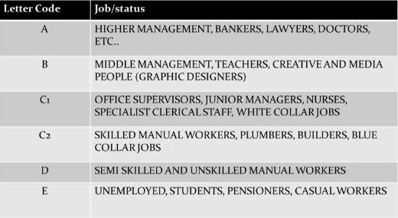
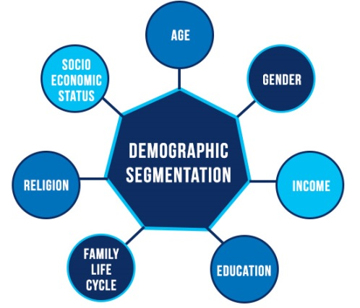
Let have a go. Using the table below what assumptions can you make about the different segment in terms of how the consume media. Can you consider what shows they would watch, what actors appeal to them, how they watch and what their interest may be? Can you put links to various media examples that may be relevant to each group?
Male, student and university , 19, weekend job at Sainsbury’s, no religious affiliations
Assumptions about this person | Media examples
Female, 32, middle management
Assumptions about this person | Media Examples
Male, 47, higher management, married with two children (aged 15 and 18)
Assumptions about this person | Media Examples

Unfortunately the activity you have just completed would have been based off stereotypes of what you believe certain people of certain groups would like to watch. As we have discussed in ‘representations’, stereotypes is not exactly a positive thing and pigeon holing ‘people’ is wrong as it ignores individuality. The example I gave in the table looks at the possibility that Riverdale from Netflix is aimed at a teenage audience but what is stopping a 90 year old women loving that show or a 40 year old man. Audiences you wouldn’t expect to be in to it, but may still enjoy it all the same.
This means media producers need to consider something known as psychographics. This is a way of categorising people by their values, attitudes, lifestyles and so on. Essentially we are now delving in to the individual more closely and will target people in a more complex way.
Watch this video https://www.youtube.com/watch?v=xhby7s9OJv0 and then carry out your own research into psychographic groupings

Genre in the media is an excellent tool to appeal to an audience. Some people like action some people like horror. To appeal to those people you simply need to follow the conventions of that genre. Conventions are elements of the film that repeat across the genre. For example in an action film you expect to see explosions. It wouldn’t be an action film without an explosion. This means a convention of an action film is an explosion. Other examples for this genre may be a car chase, fighting, guns, villains etc. You would expect to see these features in a film if it was considered an action film. As an audience member you would be disappointed if they were not there.
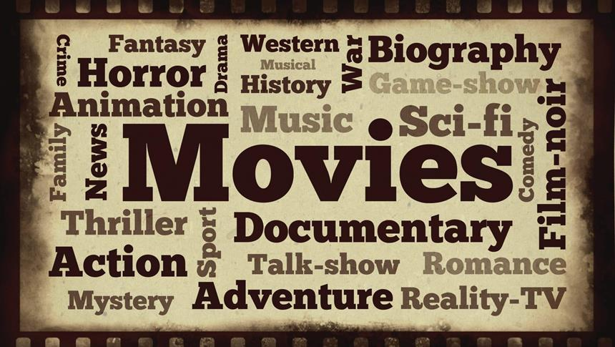

But doesn’t this get boring? Having every action film have the same content? Well…no? Steve Neale says that ‘genres are instances of repetition and difference’. The ‘difference’ is looking at ways of making those repeated elements of the genre varied between products to keep the audience engaged. A good example would be James Bond movies and the Fast and Furious movies. Both sets of movies have car chases in them but both are very different.

Codes and Conventions
Genre Specific Codes and Conventions | Difference
In this column write down the codes and conventions of the different genres. What you would expect to see in order to identify the genre (meeting audience expectations) | In this column you must give examples of how different films try to adapt and tweak these codes of repetition in order to make them unique and engaging for the audience
Sci Fi
- Space ships  - Aliens  - Off World Locations (New Planets, Galaxies, In Space)  - Futuristic technology  - Futuristic Weapons  - Utopian/Dystopian Realities  - Super Human Strength/Abilities | Star Wars  - X Wing, Millennium Flacon, Death Star  - Wookie, The Huts  - Tatooine, Jaku  - Hyper Drive  - Lightsabers, Laser Pistols  - Jedi Vs. The Republic or The rebels Vs. The empire  - The Force, The Dark Side  Star Wars Specific Codes  - Opening Titles  - Wipe Transitions
Action
Comedy
Romance
Crime Thriller
Horror
Fantasy
War
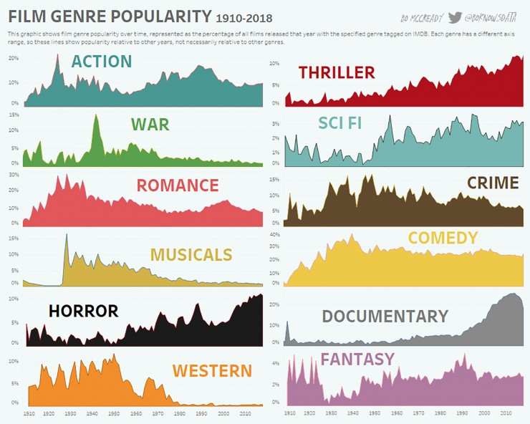

For more activities and reading on audience follow the links below to further reading or videos. Summarise your findings in the boxes below each link. You may also wish to write down any questions you have about each of the links to help further your understanding.
Media Effects – Social learning theory (How does this relate to video games today. Can you think of an example in the media that has had an impact on your behaviour or actions?)
https://www.youtube.com/watch?v=NjTxQy_U3ac

Cultivation Theory (this lady is your spirit warrior through the course. Check out her channel for everything! Also make notes on Gearge Gerbners cultivation theory)
https://www.youtube.com/watch?v=7JhbgHIVdnE&safe=true

Clay Shirky – End of audience theory (how have audiences changed today and what does that mean for media producers)
https://www.youtube.com/watch?v=xP1F0opghMY

Industry
Industry very much looks at the behind the scenes elements of the media. Ownership, regulation and funding are all areas of this topic. Whereas a film is seen by an audience after its release there are often years of work that goes in to it before it hits theatres. The reason for this is one simple word…money. The notion of media being created for pleasure or creative purposes is somewhat side-lined when you consider its ultimate goal is to make a profit and a large one at that. Even consider more modern examples of media such as Instagram and YouTube. Many users and regular uploaders are doing it for likes, followers and subscribers that could lead to a revenue stream.
Before we look at some examples take a look at some of the key words in this area of the theoretical framework.
Research the meaning of each word and write the definition in the space provided.
Conglomerate

Oligopoly

Regulation

Synergy

Convergence

Mainstream

Independent

Ideology

Hegemony

Democracy

Let’s start by taking a look in to some of the companies behind the media products. Look at the images below and categorise them in to the different media types. Be aware that some companies produce more than one media type.


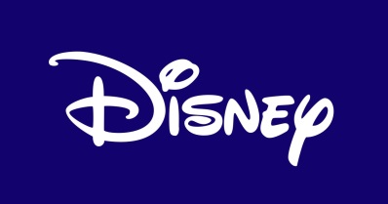













TV | Film | Music | Video Games | News


It is often the case that larger companies have divisions or subsidiaries working in different areas of the media. Firstly this could be because of the power that brings or it could be related to the overall ease of conducting your business. It makes sense if a film production company owns a television network as this will give them cheaper costs for advertisement of the film and distribution when released on the small screen. It makes sense if a film production company owns a computer game company so they can then make the game of their movie to release the two together? The more companies grow the more power they have and there is one huge powerhouse making moves in the movie industry.
Read the article in the link and make notes on the key facts and figures.
https://www.vox.com/culture/2019/3/20/18273477/disney-fox-merger-deal-details-marvel-x-men
One of the big factors that have an impact on the media industry is regulation. Can you research who regulates the following media industries and write it down below.
TV | Film | Radio | Magazines | Newspapers | Video Games

It’s clear these organisations have a role to play and essentially it is about keeping the audience (consumer) safe. Many regulators provide information to the audience about what they are going to consume therefore allowing them to make the choice on whether to watch it or not. For example - I wouldn’t take my three year old son to a 15 rated movie. It’s clear the content would not be suitable for him. These descriptors vary in different countries and across different media platforms so media industries need to be careful what they produce to ensure it reaches the right target audience. You wouldn’t make a movie aimed at families only to find that action scene you filmed is actually so intense it categorises the film as a 12A. You would lose out on your audience giving them the wrong message. Use the website below to fill in information about the different rating categories seen in British film. What can you expect from each rated film?
https://www.bbfc.co.uk/about-classification/u
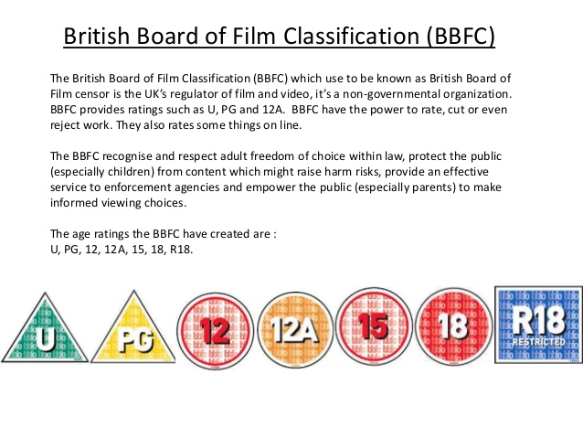

A big issue with regulation is when there is no regulation! Big media industries must adhere to the regulation in place but the development of technology has created a huge space where media is being created and viewed daily that has no clear regulatory guidelines and restrictions on who can watch and when…the internet!
The government appointed Ofcom to regulate the internet in February of 2020 due to widespread complaints about content and who can access it. Age restricted content can be accessed by simply clicking a box to verify your age or by entering a fake date of birth. Up until now parental restrictions have proved inconsistent and unreliable in safeguarding younger users of the internet. Recent issues of racism towards footballers and the persistent problem of trolling has plagued social media. Another issue is the wide spread production of content from anyone who has access to any form of modern technology. Who says if that content is suitable and who takes it down if it offends. With the sheer quantity of data being uploaded per second can it even be regulated effectively?
These are all serious questions to ask about internet use and user made content! Your final task will be an essay style question on this subject. Below are four links to stories surrounding this topic and they will be used to answer the question. Top responses will use quotes and evidence from these stories to support their views and ultimately answer the question.
Mandatory task to be submitted
Stories to be used to support your answer…
https://www.theguardian.com/media/2020/feb/12/what-powers-ofcom-have-regulate-internet-uk
https://www.theguardian.com/football/2019/dec/15/foul-play-how-racism-towards-black-footballers-is-moving-online
https://www.bbc.co.uk/news/uk-45735861
https://www.businessofapps.com/data/youtube-statistics/
Question – To what extent do you feel the internet needs stronger regulations in line with traditional media platforms. You should aim for 3 arguments for and 3 against before concluding.
Success Criteria
Targets |  | Possible sentence starters
T1 | Put forward an argument to suggest you agree with the idea that stronger regulation is needed. Support with quotes and ideas from the stories | To some extent I agree because…  This is seen in…(give evidence)  Another example to support this is…
T2 | Put forward an argument to suggest you think the internet does not need stronger regulation. Support with quotes and ideas from the stories. | However you could argue that…  To some extent I disagree because…  This is shown in the article…  Another example to support this is…
T3 | Conclude your answer by making your final judgement. This should be your opinion supported with evidence. Feel free to bring personal experiences in to support your idea. | Overall I feel that…  This is because…  This would mean that…  In the future this could lead to…
………………………………………………………………………………………………………………………………………………………………………………………………………………………………………………………………………………………………………………………………………………………………………………………………………………………………………………………………………………………………………………………………………………………………………………………………………………………………………………………………………………………………………………………………………………………………………………………………………………………………………………………………………………………………………………………………………………………………………………………………………………………………………………………………………………………………………………………………………………………………………………………………………………………………………………………………………………………………………………………………………………………………………………………………………………………………………………………………………………………………………………………………………………………………………………………………………………………………………………………………………………………………………………………………………………………………………………………………………………………………………………………………………………………………………………………………………………………………………………………………………………………………………………………………………………………………………………………………………………………………………………………………………………………………………………………………………………………………………………………………………………………………………………………………………………………………………………………………………………………………………………………………………………………………………………………………………………………………………………………………………………………………………………………………………………………………………………………………………………………………………………………………………………………………………………………………………………………………………………………………………………………………………………………………………………………………………………………………………………………………………………………………………………………………………………………………………………………………………………………………………………………………………………………………………………………………………………………………………………………………………………………………………………………………………………………………………………………………………………………………………………………………………………………………………………………………………………………………………………………………………………………………………………………………………………………………………………………………………………………………………………………………………………………………………………………………………………………………………………………………………………………………………………………………………………………………………………………………………………………………………………………………………………………………………………………………………………………………………………………………………………………………………………………………………………………………………………………………………………………………………………………………………………………………………………………………………………………………………………………………………………………………………………………………………………………………………………………………………………………………………………………………………………………………………………………………………………………………………………………………………………………………………………………………………………………………………………………………………………………………………………………………………………………………………………………………………………………………………………………………………………………………………………………………………………………………………………………………………………………………………………………………………………………………………………………………………………………………………………………………………………………………………………………………………………………………………………………………………………………………………………………………………………………………………………………………………………………………………………………………………………………………………………………………………………………………………………………………………………………………………………………………………………………………………………………………………………………………………………………………………………………………………………………………………………………………………………………………………………………………………………………………………………………………………………………………………………………………………………………………………………………………………………………………………………………………………………………………………………………………………………………………………………………………………………………………………………………………………………………………………………………………………………………………………………………………………………………………………………………………………………………………………………………………………………………………………………………………………………………………………………………………………………………………………………………………………………………………………………………………………………………………………………………………………………………………………………………………………………………………………………………………………………………………………………………………………………………………………………………………………………………………………………………………………………………………………………………………………………………………………………………………………………………………………………………………………………………………………………………………………………………………………………………………………………………………………………………………………………………………………………………………………………………………………………………………………………………………………………………………………………………………………………………………………………………………………………………………………………………………………………………………………………………………………………………………………………………………………………………………………………………………………………………………………………………………………………………………………………………………………………………………………………………………………………………………………………………………………………………………………………………………………………………………………………………………………………………………………………………………………………………………………………………………………………………………………………………………………………………………………………………………………………………………………………………………………………………………………………………………………………………………………………………………………………………………………………………………………………………………………………………………………………………………………………………………………………………………………………………………………………………………………………………………………………………………………………………………………………………………………………………………………………………………………………………………………………………………………………………………………………………………………………………………………………………………………………………………………………………………………………………………………………………………………………………………………………………………………………………………………………………………………………………………………………………………………………………………………………………………………………………………………………………………………………………………………………………………………………………………………………………………………………………………………………………………………………………………………………………………………………………………………………………………………………………………………………………………………………………………………………………………………………………………………………………………………………………………………………………………………………………………………………………………………………………………………………………………………………………………………………………………………………………………………………………………………………………………………………………………………………………………………………………………………………………………………………………………………………………………………………………………………………………………………………………………………………………………………………………………………………………………………………………………………………………………………………………………………………………………………………………………………………………………………………………………………………………………………………………………………………………………………………………………………………………………………………………………………………………………………………………………………………………………………………………………………………………………………………………………………………………………………………………………………………………………………………………………………………………………………………………………………………………………………………………………………………………………………………………………………………………………………………………………………………………………………………………………………………………………………………………………………………………………………………………………………………………………………………………………………………………………………………………………………………………………………………………………………………………………………………………………………………………………………………………………………………………………………………………………………………………………………………………………………………………………………………………………………………………………………………………………………………………………………………………………………………………………………………………………………………………………………………………………………………………………………………………………………………………………………………………………………………………………………………………………………………………………………………………………………………………………………………………………………………………………………………………………………………………………………………………………………………………………………………………………………………………………………………………………………………………………………………………………………………………………………………………………………………………………………………………………………………………………………………………………………………………………………………………………………………………………………………………………………………………………………………………………………………………………………………………………………………………………………………………………………………………………………………………………………………………………………………………………………………………………………………………………………………………………………………………………………………………………………………………………………………………………………………………………………………………………………………………………………………………………………………………………………………………………………………………………………………………………………………………………………………………………………………………………………………………………………………………………………………………………………………………………………………………………………………………………………………………………………………………………………………………………………………………………………………………………………………………………………………………………………………………………………………………………………………………………………………………………………………………………………………………………………………………………………………………………………………………………………………………………………………………………………………………………………………………………………………………………………………………………………………………………………………………………………………………………………………………………………………………………………………………………………………………………………………………………………………………………………………………………………………………………………………………………………………………………………………………………………………………………………………………………………………………………………………………………………………………………………………………………………………………………………………………………………………………………………………………………………………………………………………………………………………………………………………………………………………………………………………………………………………………………………………………………………………………………………………………………………………………………………………………………………………………………………………………………………………………………………………………………………………………………………………………………………………………………………………………………………………………………………………………………………………………………………………………………………………………………………………………………………………………………………………………………………………………………………………………………………………………………………………………………………………………………………………………………………………………………………………………………………………………………………………………………………………………………………………………………………………………………………………………………………………………………………………………………………………………………………………………………………………………………………………………………………………………………………………………………………………………………………………………………………………………………………………………………………………………………………………………………………………………………………………………………………………………………………………………………………………………………………………………………………………………………………………………………………………………………………………………………………………………………………………………………………………………………………………………………………………………………………………………………………………………………………………………………………………………………………………………………………………………………………………………………………………………………………………………………………………………………………………………………………………………………………………………………………………………………………………………………………………………………………………………………………………………………………………………………………………………………………………………………………………………………………………………………………………………………………………………………………………………………………………………………………………………………………………………………………………………………………………………………………………………………………………………………………………………………………………………………………………………………………………………………………………………………………………………………………………………………………………………………………………………………………………………………………………………………………………………………………………………………………………………………………………………………………………………………………………………………………………………………………………………………………………………………………………………………………………………………………………………………………………………………………………………………………………………………………………………………………………………………………………………………………………………………………………………………………………………………………………………………………………………………………………………………………………………………………………………………………………………………………………………………………………………………………………………………………………………………………………………………………………………………………………………………………………………………………………………………………………………………………………………………………………………………………………………………………………………………………………………………………………………………………………………………………………………………………………………………………………………………………………………………………………………………………………………………………………………………………………………………………………………………………………………………………………………………………………………………………………………………………………………………………………………………………………………………………………………………………………………………………………………………………………………………………………………………………………………………………………………………………………………………………………………………………………………………………………………………………………………………………………………………………………………………………………………………………………………………………………………………………………………………………………………………………………………………………………………………………………………………………………………………………………………………………………………………………………………………………………………………………………………………………………………………………………………………………………………………………………………………………………………………………………………………………………………………………………………………………………………………………………………………………………………………………………………………………………………………………………………………………………………………………………………………………………………………………………………………………………………………………………………………………………………………………………………………………………………………………………………………………………………………………………………………………………………………………………………………………………………………………………………………………………………………………………………………………………………………………………………………………………………………………………………………………………………………………………………………………………………………………………………………………………………………………………………………………………………………………………………………………………………………………………………………………………………………………………………………………………………………………………………………………………………………………………………………………………………………………………………………………………………………………………………………………………………………………………………………………………………………………………………………………………………………………………………………………………………………………………………………………………………………………………………………………………………………………………………………………………………………………………………………………………………………………………………………………………………………………………………………………………………………………………………………………………………………………………………………………………………………………………………………………………………………………………………………………………………………………………………………………………………………………………………………………………………………………………………………………………………………………………………………………………………………………………………………………………………………………………………………………………………………………………………………………………………………………………………………………………………………………………………………………………………………………………………………………………………………………………………………………………………………………………………………………………………………………………………………………………………………………………………………………………………………………………………………………………………………………………………………………………………………………………………………………………………………………………………………………………………………………………………………………………………………………………………………………………………………………………………………………………………………………………………………………………………………………………………………………………………………………………………………………………………………………………………………………………………………………………………………………………………………………………………………………………………………………………………………………………………………………………………………………………………………………………………………………………………………………………………………………………………………………………………………………………………………………………………………………………………………………………………………………………………………………………………………………………………………………………………………………………………………………………………………………………………………………………………………………………………………………………………………………………………………………………………………………………………………………………………………………………………………………………………………………………………………………………………………………………………………………………………………………………………………………………………………………………………………………………………………………………………………………………………………………………………………………………………………………………………………………………………………………………………………………………………………………………………………………………………………………………………………………………………………………………………………………………………………………………………………………………………………………………………………………………………………………………………………………………………………………………………………………………………………………………………………………………………………………………………………………………………………………………………………………………………………………………………………………………………………………………………………………………………………………………………………………………………………………………………………………………………………………………………………………………………………………………………………………………………………………………………………………………………………………………………………………………………………………………………………………………………………………………………………………………………………………………………………………………………………………………………………………………………………………………………………………………………………………………………………………………………………………………………………………………………………………………………………………………………………………………………………………………………………………………………………………………………………………………………………………………………………………………………………………………………………………………………………………………………………………………………………………………………………………………………………………………………………………………………………………………………………………………………………………………………………………………………………………………………………………………………………………………………………………………………………………………………………………………………………………………………………………………………………………………………………………………………………………………………………………………………………………………………………………………………………………………………………………………………………………………………………………………………………………………………………………………………………………………………………………………………………………………………………………………………………………………………………………………………………………………………………………………………………………………………………………………………………………………………………………………………………………………………………………………………………………………………………………………………………………………………………………………………………………………………………………………………………………………………………………………………………………………………………………………………………………………………………………………………………………………………………………………………………………………………………………………………………………………………………………………………………………………………………………………………………………………………………………………………………………………………………………………………………………………………………………………………………………………………………………………………………………………………………………………………………………………………………………………………………………………………………………………………………………………………………………………………………………………………………………………………………………………………………………………………………………………………………………………………………………………………………………………………………………………………………………………………………………………………………………………………………………………………………………………………………………………………………………………………………………………………………………………………………………………………………………………………………………………………………………………………………………………………………………………………………………………………………………………………………………………………………………………………………………………………………………………………………………………………………………………………………………………………………………………………………………………………………………………………………………………………………………………………………………
For more activities and reading on industry follow the links below to further reading or videos. Summarise your findings in the boxes below each link. You may also wish to write down any questions you have about each of the links to help further your understanding.
Mergers and Acquisitions – Trust me this video does make sense! You may just need to watch it a few times and pause a lot. It is very good!
https://www.youtube.com/watch?v=snVQ3HwaqN0

PEGI (you have considered film ratings but now here is a chance to see how games are rated differently)
https://www.youtube.com/watch?v=bwSOrWB3cxk

How does a film get made – (first in a series of videos looking at the work that goes in to making a film all with the idea of making a big profit upon its release)
https://www.youtube.com/watch?v=TARsoxST0tQ

Contextual Development – Advertisement
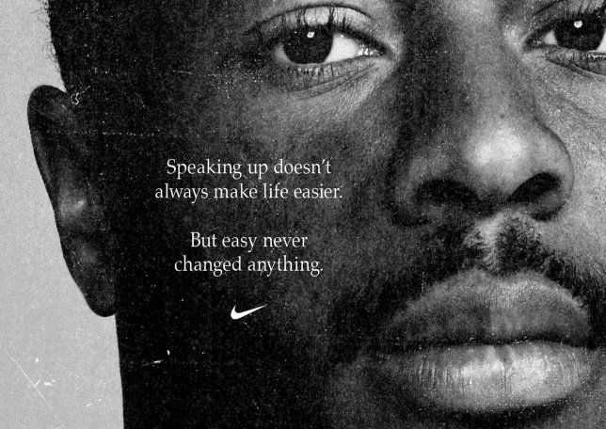
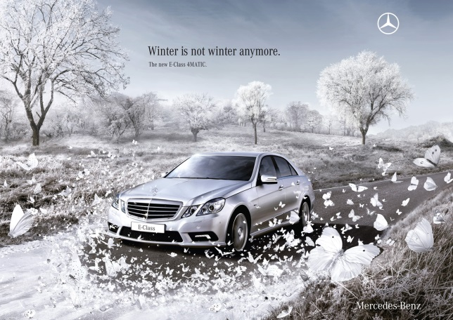
Advertisement is a key area of the media that heavily relies on the use of media language to target its audience. From the knowledge you have gained so far consider the two adverts below. Can you analyse them and discuss the techniques used to create the messages within them. Remember everything is there for a reason.

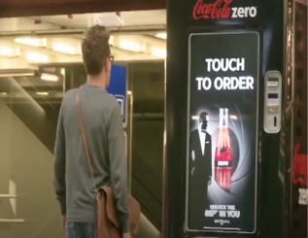
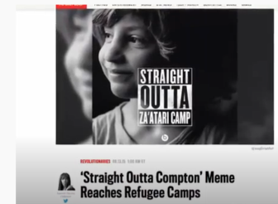
Advertisement is much more than posters and TV ads. With the development of technology advertisement has had to become clever and draw the audience in. Watch the viral ad campaigns bellow for Straight Outta Compton and James Bond. Can you think why they were successful and find any other examples of this type of campaign.
https://www.youtube.com/watch?v=m2XQgCHX2TI
https://www.youtube.com/watch?v=_pCRfiQCSbU

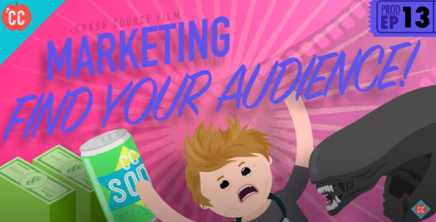
Film promotion takes up a huge amount of money from the films budget often being at least 50% of the production budget. That means if a film cost $100 million dollars to make, they would probably spend at least $50 million on promoting and advertising the film. Watch the video below to see all the different ways in which a film is promoted.

https://www.youtube.com/watch?v=04C3B1Ztwf0
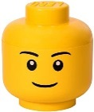
Can you find out the different ways the Lego movie was promoted? This forms part of your first exam!
Contextual Development - The 1960’s
As part of your course it is important to recognise that media is made in context. We have already discussed the idea that media can shape society. It can also be argued that media could be a reflection or representation of society. As part of your A level you will study a number of different products set in different time period all with different contexts. These could be social, cultural, political, technological or economical.
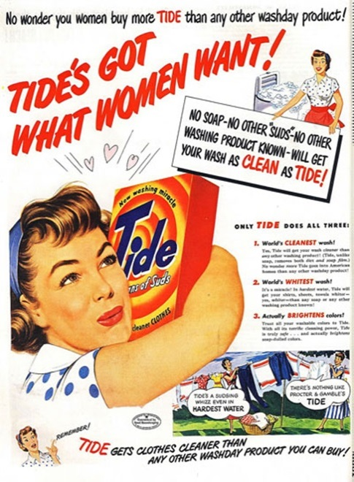
This advert is from the 1950’s and is a great representation of the kind of adverts you would find of the time period. Women were often shown in domestic roles; cooking, cleaning, washing or generally being a wife or mother. Very little else was shown in the media keeping women from striving to achieve more in life. The 1960s saw the first change in this representation as women were starting to be allowed more freedoms. It was the first time the contraceptive pill was introduced and the first time women could legally hold their own bank account. The swinging sixties were a historic time period especially for the UK which was at the epicentre of the cultural world.
This is the first product we will be studying as part of you’re a level so head to the media hub and read all about it. Consider developing your knowledge beyond the product. How much can you find out about Tide and the 50’s?

Possible tasks
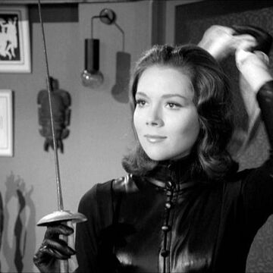
- Research a range of adverts from the 50s and consider how they share various conventions. Are characters portrayed in the same way and what does it say about how society should behave.
- Can you find out more about Tide? Who are they and what do they make? Are they owned by a larger company and what do they do? Do they still exist today and who are their competitors.
- Research the 1950’s and consider what life was like back then. Focus your research specifically on 1950’s Brittan.
- How are washing products marketed today? Can you consider they key differences and try to explain why this is.

Contextual Development - Video Killed the Radio Star
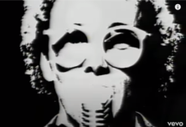
In the words of the Buggles song… ‘Video killed the radio star’. Essentially what we are saying is when something bigger and better comes along something else has to go and that is true of the media and technology. Cartridge based games consoles, mini disc player, VHS? No didn’t think so? Even popular media platforms today such as blu-rays are suffering due to the introduction of streaming sites and VOD. For this section of contextual development I want to give you the oppurtunity to consider 3 pieces of failed/discontinued technology and consider why they no longer exist as well as examples of developing technology and discuss why they are so popular and make a difference to the way we consume media. Use the two below for each section plus one of your choice for each section.
Discontinued technology
For each one, research the product and its background. Find details on its successes and failures and ultimate why it no longer exists. Did it get replaced or did the consumer simply not like it?
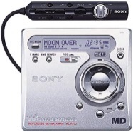
Mini Disc Player

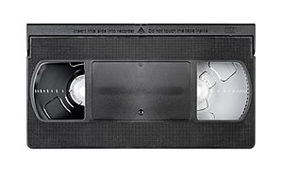
VHS

Current/New Technology
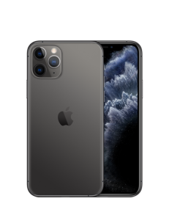
For each one, research the product and its background. Find details on its successes using facts and figures such as sales and users. What impact is it having on its competitors and how does it affect the way we consume the media?
Smart Phone


Streaming Services

Contextual Development – Wider Reading
As a media student is essential that you develop your independent learning skills and carry out wider reading around your subject. Here is a list of books and websites which will help you prepare for the theoretical aspect of the Media Studies course
Books
Media, Gender and Identity by David Gauntlett
Feminism is for Everybody by bell hooks
Feminist Media Studies by Liesbet van Zoonen
Gender Trouble by Judith Butler
After Empire by Paul Gilroy
Media Regulation by Lunt and Livingstone
Here Comes Everybody by Clay Shirky
Cognitive Surplus: Creativity and Generosity in a Connected Age by Clay Shirky
Representation: Cultural Representations and Signifying Practices Edited by Stuart Hall
Power without Responsibility: Press, Broadcasting and the Internet in Britain by James Curran
The Cultural Industries by David Hesmondhalgh
Convergence Culture: Where Old and New Media Collide by Henry Jenkins
Websites
The Media Guardian: https://www.theguardian.com/uk/media
EMC’s Media Magazine: https://www.englishandmedia.co.uk/media-magazine (well worth subscribing to – we have hard copies delivered to school available to loan from MD1)
British Film Institute: http://www.bfi.org.uk/
Eduqas Qualification Page : https://www.eduqas.co.uk/qualifications/media-studies-as-a-level/#tab_overview
Churchdown Media Hub: https://www.churchdownmediahub2.com/
(Password – churchdownmediahub)
Contextual Development – Wider Watching
It seems mad people would opt to do a course without a keen interest in the subject. Especially media! I love films! It would greatly help if you did too…or music or TV or anything related to the media. Your own experiences and engagements with the media will feed in to the topics we cover and help you to apply theories and course content in different contexts.
Many people ask me to recommend films to watch that will help them in the course. Here is a list of films I enjoy or find that they challenge ideology or conventions in some way. Watch any of these for some good discussions to be had in the future. I always have more if you plough through these. Happy watching. (Age restrictions may apply)
- Fight Club
- Shutter Island
- Batman the Dark Knight
- The Joker
- Looper
- Reservoir dogs
- Kingdom of Heaven
- Eternal Sunshine of the Spotless Mind
- 23
- The Truman Show
- Stranger Than Fiction
- Momento
- Inception
- Pulp Fiction
- Forrest Gump
- The Matrix
- Seven
- Saving Private Ryan
- The Departed
- The Prestige
- Whiplash
- Sixth Sense
- Back to the Future
- Indiana Jones – The Last Crusade
- Minority Report

Contextual Development – Media Theorists
During the Media Studies course you will encounter many media theorists that have studied various areas of the media. In order to give you a head start you should research as many of these theorists as possible and produce a short paragraph on each that outlines their key theories linked with each of the concepts below:
Media Language
Semiology –Roland Barthes
Narratology –Todorov
Genre Theory –Steve Neale
Structuralism –Claude Levi-Strauss
Postmodernism –Baudrillard
Media Representations
Theories of Representation –Stuart Hall
Theories of Identity –David Gauntlett
Feminist Theory –Van Zoonen
Media Audiences
Media Effects –Bandura
Cultivation Theory –George Gerbner
Fandom –Henry Jenkins
‘End of Audience’ Theories –Clay Shirky
Media Industries
Power and Media Industries –James Curran and Jean Seaton
Regulation –Livingstone and Lunt
Cultural Industries –Hesmondhalgh

