
Transition Pack
For
A – Level Film

Mandatory Tasks – Submit to LJW@churchdownschool.com
Task | Page No. | Completed (tick) | Score (if applicable)
Realist Vs Expressionist | 8
Who is Tarantino? | 18
Scene Analysis | 24

Optional Tasks
Task | What did you read, see or do?
Book recommendations
Movie Recommendations
Online video/article recommendations

Welcome to A Level Film
Film studies is a growing area of interest in a world stuffed with media and content made for our consumption. The world of film is ever changing and developing to reflect the society in which it is made or to be used as an experimental tool of expression. Film has sparked debate amongst followers since its inception tackling important content across a range of genres and it is often a window into a world beyond our own or into worlds that do not exist. Film studies will allow you to explore various techniques, genres, styles, contextual issues and of course the changing face of the industry itself.
Day one of year 12 I will be asking you your favourite film. We all have our likes and dislikes but to really narrow it down to one favourite you can watch over and over and really explain the reasons why is a challenging task. In my own recommendations in the back of this pack I could not keep it below 20! In the box below write down your favourite film and why to be prepared for day one!
Favourite film and why…

Film Studies is assessed over three key elements. Two exams and one practical. We stress the emphasis on the examined units as they are worth 70% of the course. They will test your knowledge of the film across a series of ‘set products’. These set products must be known inside out to succeed and it is worth watching, researching or engaging with these products now so you are familiar with them when we come to study them. Use the table below to see the set products and begin your research into each one. It is recommended that you try to acquire these prior to the course as you will be expected to watch them numerous times at home. Many can be acquired cheaply through sites such as eBay or via streaming services such as amazon prime. You can also find out more about each of the films and what knowledge is required by accessing the film section at the media hub in the link below.
. www.churchdownmediahub2.com password – churchdownmediahub
Film Studies – Set Products (film list) 2024/2026
Pans Labrynth | Shaun of the Dead
City of God | Trainspotting
Alien | Joker
Vertigo | Captain Fantastic
Momento | Amy
 | Sunrise
Resources
At Churchdown we are product to be able to offer you a fully integrated and accessible on line learning platform in the form of ‘the churchdown media hub’. This should be accessed daily as a film student completing independent work, pre-reading and accessing the resources for revision and assessments. Each page is loaded with key information on each of the set products, sample answers, models, videos and opportunities to develop your knowledge beyond the set curriculum.
www.churchdownmediahub.com
password – churchdownmediahub
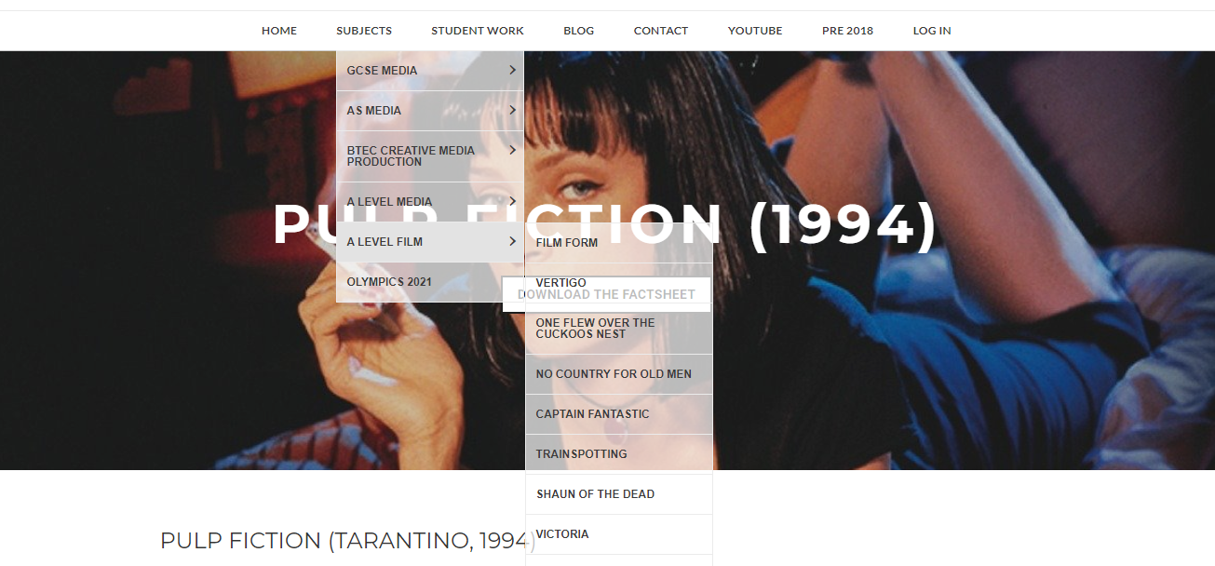
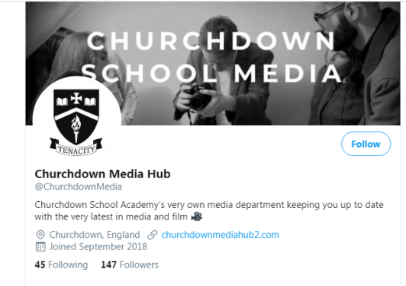
Our twitter account is also extremely popular and useful for communication with teachers, access to wider resources and to further deepen your knowledge within the subject. We strongly recommend that as a sixth form student in film you follow this account and engage with the content. Feel free to share anything you feel may be of interest to the film cohort at Churchdown School.

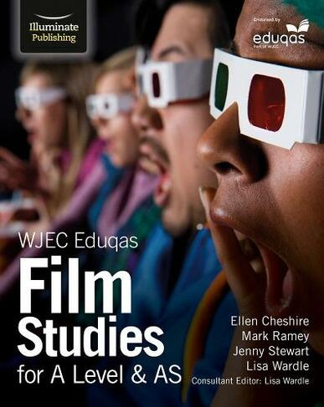
As part of the course you are also recommended to get the following text book to support your learning. This book covers both years of study. They are used in lessons and we do have limited copies for students to use in school.
It is available from a number of online retailers. Simply search ‘Film Studies A Level text book eduqas)
Note: How to use this pack – there will be many videos listed to add context to your course and understanding prior to studying in lessons. Use the blank boxes to make notes on optional film/video suggestions and the videos highlighted in red are related to a mandatory task.
A History of Film
CHAPTER 1: The Very Earliest Films (The 1890s)
There is debate about the date of the origin of film. Photography had been around as a medium since the 1820s and throughout the 19th century there were many experiments in capturing and showing moving images. Taking advantage of the invention of roll film by American company Eastman in 1884, Frenchman Louis Le Prince produced very short moving image sequences with a camera he had invented himself. These including footage of a horsedrawn tram crossing a bridge in Leeds made in 1888. In the mid-1890s American Thomas Edison produced moving image projections lasting a matter of seconds and depicting simple events, a man sneezing, a couple kissing. However, it is brothers Auguste and Louis Lumière who are often credited with producing the first commercially successful films, shot and projected on a camera/projector they had developed themselves. The Lumière brothers screened a programme of their films in a basement room at the Grand Café in Paris in December 1895. These included single shot documentaries (or actualités – films of real events) of workers leaving the Lumière factory and a train pulling into a station. The programme also included what amounted to the world’s first narrative film, a 45 second comedy, L’Arroseur Arrosé (Tables Turned on the Gardener).
Film to Watch:
The Lumière Brothers – Workers Leaving the Lumière Factory, Lyon (1895):
https://www.youtube.com/watch?v=DEQeIRLxaM4
Summary notes of the video

CHAPTER 2: German Expressionism (The 1920s)
German Expressionism was one of the most significant of the modernist film movements of the silent film era. Inspired by developments in painting (there was a German Expressionist movement in art as well as filmmaking) and theatre set design in the 1910s and 1920s, German Expressionist filmmakers developed a style of filmmaking that was much less naturalistic and much more expressive, stylised and exaggerated than the “idealised realism” that was to become the style of classical Hollywood filmmaking. In German Expressionism film form was used in a more overt or exaggerated way to emphasise characters’ inner feelings or to provoke specific audience responses. Mise en scene, shot composition and high contrast lighting were often used in ways that created strong graphic images and encouraged audiences to maintain rather than suspend their sense of disbelief. Many filmmakers aligned to the German Expressionist movement ended up working in America, either through choice or because they had fled the Nazi regime in the 1930s and 1940s, with their approach having a major influence on the style and content of American films of the period.
Film to Watch:
Robert Wiene – The Cabinet of Doctor Caligari (1920):
https://www.youtube.com/watch?v=LzMYM75SjhY
Summary notes of the video

CHAPTER 3: Soviet Montage (The 1920s)
Another key film movement in the silent era is what has become known as Soviet Montage cinema. Beginning in 1917 Russia underwent a political revolution that saw the replacement of a feudalistic political system based around what was close to an absolute monarchy with a communist system of government. The revolution saw the abolition and execution of the Russian monarchy and was a period of the most profound political and social change. In the beginning at least the communist revolution opened up the possibility of a radically changed society, one where wealth, power and opportunity could be more evenly distributed and where the people could have a role in making political decisions. Russian artists were drawn into this spirit of modernist change and renewal, with exciting and innovative developments in graphic design, painting, photography and music that aimed to reform the arts in the same way that the Bolshevik revolution was reforming politics and society. Filmmaking was part of this spirit of renewal and revolution. Many Soviet films of this time are propagandist, supporting the cause of the communist revolution. However, Russian filmmakers of the period, led by the director of the Moscow Film School, Lev Kuleshov and his most famous pupil Sergei Eisenstein, were pioneering new methods of creating meaning in film that broke away from the increasingly naturalistic and continuity based approach to narrative, editing and cinematography that were becoming conventional by the end of the 1910s. Significantly Kuleshov and Eisenstein were aware of the power of the edit as a means of emotionally guiding an audience and developed techniques that increased the expressive and emotional impact of film through using jump cuts and cross cutting to create montages of juxtaposed images. This approach can be seen most famously in two scenes in films by Eisenstein, the “Odessa Steps” scene from his 1925 film The Battleship Potemkin: https://www.youtube.com/watch?v=Ps-v-kZzfec and a scene from his 1924 film Strike, where footage of an attack on a crowd is intercut with footage of animal slaughter to emphasise its brutality: https://www.youtube.com/watch?v=jWiDciPuSW4.
Film to Watch:
Sergei Eisenstein – The Battleship Potemkin (1925)
https://www.youtube.com/watch?v=ca0c4vEc5Is
Summary of the video

CHAPTER 4: American Silent Comedy (The 1910s and 1920s)
Comedy was one of the most significant genres of early cinema perhaps partly because the silence of the new medium lent itself to visual tricks and sight gags and partly because of the popularity of vaudeville theatre at the end of the 19th and beginning of the 20th centuries. Vaudeville was a type of popular theatre that combined a variety of short acts, often featuring comedy shows based around slapstick humour. Many silent comedy stars, including Charlie Chaplin and Buster Keaton came from vaudeville or music hall backgrounds. Comedies in the silent era would often be “two reelers”, short films played as part of a longer programme of films that might have also included newsreels and a longer feature film. Early comedies, such as the Keystone Kops films produced by the Keystone Studios were simple, fast paced and heavily slapstick. However, as the comedy stars of the day became established and started to gain more creative control over their own output they began to produce longer and far more sophisticated and ambitious comedy features. These included Chaplin films such as The Kid (1921) and The Gold Rush (1925), Harold Lloyd’s Safety Last (1923) and what is widely acknowledged as Keaton’s masterpiece, his 1926 film The General.
Film to Watch:
Buster Keaton - Steamboat Bill Jr. (1928):
https://www.youtube.com/watch?v=n9QPfiLuQ9c

Summarise the video

CHAPTER 5: Other Important Silent Films (The 1920s)

As the “rules” of filmmaking hadn’t been determined and as film hadn’t yet become fully industrialised and commercialised arguably the silent era was a period of unparalleled creative freedom, ambition, innovation and experimentation. Many of the films made in this period took a very different stylistic approach to that we’re familiar with today – filmmakers were genuinely experimenting with different ways of structuring narrative and developing a visual language with which to create meaning. In 1927 for example the Danish filmmaker Carl Theodor Dreyer used transcripts from the trial of Joan of Arc in 1431 to create a film that combined highly expressive cinematography and editing, particularly the use of intense close ups, with extreme realism of performance to depict Joan’s trial, torture and execution. French filmmaker Abel Gance made pioneering use of a bewildering range of technical innovations in his hugely ambitious 1928 film Napoleon about the life of the early 19th century French emperor. These included, amongst other things, shooting in a widescreen format, filming using multiple cameras, using handheld camera work and other forms of innovative camera movement and using double exposures, split screens and coloured film tinting. German Expressionist filmmaker FW Murnau, who had made Nosferatu, moved from Germany to America where he was given unlimited funds and complete creative freedom by William Fox to make what amounted to an American German Expressionist film, Sunrise. The film, which made use of exaggerated, expressionist sets, double exposures, extreme perspectives and extended cross dissolves amongst other techniques is often voted amongst the greatest films of all time in critics’ polls. The following articles, one proclaiming the 1920s as the greatest ever film decade and the other outlining significant films from the silent era are an interesting read:
https://www.theguardian.com/film/filmblog/2018/apr/04/my-favourite-film-decade-1920s-nosferatu-the-general
https://www.theguardian.com/film/filmblog/2013/nov/22/top-10-silent-movies-films

Mandatory Task 1
THIS IS ONE OF YOUR STUDY TEXTS FOR FILM A LEVEL SO VERY IMPORTANT TO WATCH!
FW Murnau – Sunrise (1928): https://www.youtube.com/watch?v=y8Vjxw6cL7g
Critical debate – The realist and the expressive. For silent film you are required to study the set product in terms of the critical debate – the realist and the expressive.
‘In the 1940s, the French film critic André Bazin set in motion a major debate when he argued that both German Expressionist and Soviet Montage filmmaking went against what he saw as the ‘realist’ calling of cinema. This opposition between the realist and the expressive has informed thinking about film from the beginnings of cinema when the documentary realism of the Lumière Brothers was set in opposition to the fantasy films of Méliès.’
Task - Research the meaning of both of the terms(defining both below with examples) and put forward and argument to suggest if ‘sunrise’ is either realist and expressive. Use a particular scene from the film to support your answer.
……………………………………………………………………………………………………………………………………………………………………………………………………………………………………………………………………………………………………………………………………………………………………………………………………………………………………………………………………………………………………………………………………………………………………………………………………………………………………………………………………………………………………………………………………………………………………………………………………………………………………………………………………………………………………………………………………………………………………………………………………………………………………………………………………………………………………………………………………………………………………………………………………………………………………………………………………………………………………………………………………………………………………………………………………………………………………………………………………………………………………………………………………………………………………………………………………………………………………………………………………………………………………………………………………………………………………………………………………………………………………………………………………………………………………………………………………………………………………………………………………………………………………………………………………………………………………………………………………………………………………………………………………………………………………………………………………………………………………………………………………………………………………………………………………………………………………………………………………………………………………………………………………………………………………………………………………………………………………………………………………………………………………………………………………………………………………………………………………………………………………………………………………………………………………………………………………………………………………………………………………………………………………………………………………………………………………………………………………………………………………………………………………………………………………………………………………………………………………………………………………………………………………………………………………………………………………………………………………………………………………………………………………………………………………………………………………………………………………………………………………………………………………………………………………………………………………………………………………………………………………………………………………………………………………………………………………………………………………………………………………………………………………………………………………………………………………………………………………………………………………………………………………………………………………………………………………………………………………………………………………………………………………………………………………………………………………………………………………………………………………………………………………………………………………………………………………………………………………………………………………………………………………………………………………………………………………………………………………………………………………………………………………………………………………………………………………………………………………………………………………………………………………………………………………………………………………………………………………………………………………………………………………………………………………………………………………………………………………………………………………………………………………………………………………………………………………………………………………………………………………………………………………………………………………………………………………………………………………………………………………………………………………………………………………………………………………………………………………………………………………………………………………………………………………………………………………………………………………………………………………………………………………………………………………………………………………………………………………………………………………………………………………………………………………………………………………………………………………………………………………………………………………………………………………………………………………………………………………………………………………………………………………………………………………………………………………………………………………………………………………………………………………………………………………………………………………………………………………………………………………………………………………………………………………………………………………………………………………………………………………………………………………………………………………………………………………………………………………………………………………………………………………………………………………………………………………………………………………………………………………………………………………………………………………………………………………………………………………………………………………………………………………………………………………………………………………………………………………………………………………………………………………………………………………………………………………………………………………………………………………………………………………………………………………………………………………………………………………………………………………………………………………………………………………………………………………………………………………………………………………………………………………………………………………………………………………………………………………………………………………………………………………………………………………………………………………………………………………………………………………………………………………………………………………………………………………………………………………………………………………………………………………………………………………………………………………………………………………………………………………………………………………………………………………………………………………………………………………………………………………………………………………………………………………………………………………………………………………………………………………………………………………………………………………………………………………………………………………………………………………………………………………………………………………………………………………………………………………………………………………………………………………………………………………………………………………………………………………………………………………………………………………………………………………………………………………………………………………………………………………………………………………………………………………………………………………………………………………………………………………………………………………………………………………………………………………………………………………………………………………………………………………………………………………………………………………………………………………………………………………………………………………………………………………………………………………………………………………………………………………………………………………………………………………………………………………………………………………………………………………………………………………………………………………………………………………………………………………………………………………………………………………………………………………………………………………………………………………………………………………………………………………………………………………………………………………………………………………………………………………………………………………………………………………………………………………………………………………………………………………………………………………………………………………………………………………………………………………………………………………………………………………………………………………………………………………………………………………………………………………………………………………………………………………………………………………………………………………………………………………………………………………………………………………………………………………………………………………………………………………………………………………………………………………………………………………………………………………………………………………………………………………………………………………………………………………………………………………………………………………………………………………………………………………………………………………………………………………………………………………………………………………………………………………………………………………………………………………………………………………………………………………………………………………………………………………………………………………………………………………………………………………………………………………………………………………………………………………………………………………………………………………………………………………………………………………………………………………………………………………………………………………………………………………………………………………………………………………………………………………………………………………………………………………………………………………………………………………………………………………………………………………………………………………………………………………………………………………………………………………………………………………………………………………………………………………………………………………………………………………………………………………………………………………………………………………………………………………………………………………………………………………………………………………………………………………………………………………………………………………………………………………………………………………………………………………………………………………………………………………………………………………………………………………………………………………………………………………………………………………………………………………………………………………………………………………………………………………………………………………………………………………………………………………………………………………………………………………………………………………………………………………………………………………………………………………………………………………………………………………………………………………………………………………………………………………………………………………………………………………………………………………………………………………………………………………………………………………………………………………………………………………………………………………………………………………………………………………………………………………………………………………………………………………………………………………………………………………………………………………………………………………………………………………………………………………………………………………………………………………………………………………………………………………………………………………………………………………………………………………………………………………………………………………………………………………………………………………………………………………………………………………………………………………………………………………………………………………………………………………………………………………………………………………………………………………………………………………………………………………………………………………………………………………………………………………………………………………………………………………………………………………………………………………………………………………………………………………………………………………………………………………………………………………………………………………………………………………………………………………………………………………………………………………………………………………………………………………………………………………………………………………………………………………………………………………………………………………………………………………………………………………………………………………………………………………………………………………………………………………………………………………………………………………………………………………………………………………………………………………………………………………………………………………………………………………………………………………………………………………………………………………………………………………………………………………………………………………………………………………………………………………………………………………………………………………………………………………………………………………………………………………………………………………………………………………………………………………………………………………………………………………………………………………………………………………………………………………………………………………………………………………………………………………………………………………………………………………………………………………………………………………………………………………………………………………………………………………………………………………………………………………………………………………………………………………………………………………………………………………………………………………………………………………………………………………………………………………………………………………………………………………………………………………………………………………………………………………………………………………
CHAPTER 6: Classic Hollywood/Classical Hollywood (1930-1960)

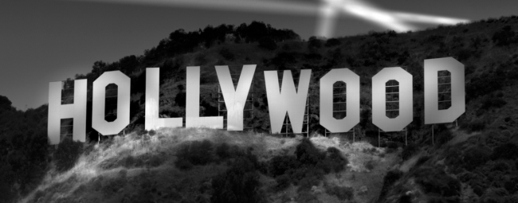
By 1930 film as a medium was nearly 40 years old and many of its conventions were becoming established. In its early history film had developed in many locations around the world but as the 20th century progressed it was the American film industry that became dominant. A distinct Hollywood style had developed, defined by a set of conventions that created a sense of exaggerated or idealised realism, arguably a style of cinema that is with us today and a style that we are all familiar with. By the 1930s film production had become increasingly industrialised, with eight studios producing the vast majority of films. The Big Five: 20th Century Fox, Metro Goldwyn Mayer, Paramount, RKO and Warner Brothers were vertically integrated – meaning that they produced and distributed films and owned chains of cinemas that exhibited them. The Little Three: Columbia, United Artists and Universal produced and distributed films but did not own cinemas. The studio system produced films in a highly organised and efficient way that used a range of strategies to reduce the financial risk of film production and maximise the chance of securing the biggest possible audiences and making a profit. Each studio had a president or head who took key decisions about scheduling, casting and other elements of production. Directors, actors and other members of the production team tended to be contracted to studios and had little say in creative decisions, they were in effect making the studio’s film.
Film to Watch:
Michael Curtiz - Casablanca (1942)
Only a select few directors were able to operate as “auteurs” and work on projects that were their own creative visions, although they often had to work against considerable studio interference (as was famously the case with Orson Welles) to do so. There are a number of significant films produced in this way during the classic or classical period, two of them are:
Film to Watch:
Orson Welles – A Touch of Evil (1958)
THIS IS YOUR STUDY TEXT FOR FILM A LEVEL SO VERY IMPORTANT TO WATCH!
Alfred Hitchcock – Vertigo (1958)
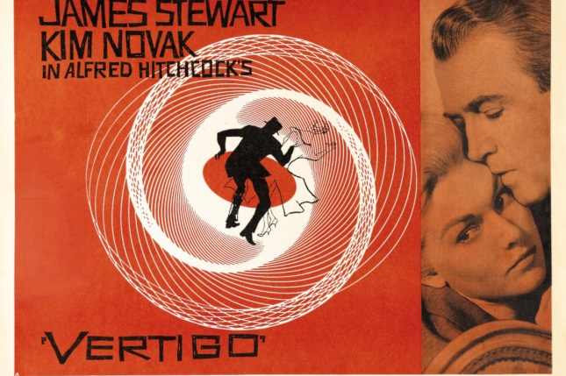
CHAPTER 7: Film Noir (1940s and 1950s)

Film noir is a body of unconventional crime films released in the 1940s and 1950s and made in a style that was largely at odds with the classical Hollywood style. Most original noirs were made by the American film industry although some key films were made outside of it. Film noir is a term that wasn’t used by the film industry or those who made the films at the time they were made, rather it was applied by French film critics in the 1940s (film noir is a French term that translates as black film or dark film). Famous film noirs include The Maltese Falcon 1941, Double Indemnity 1944, The Big Sleep 1946, The Killers 1946, Out of the Past 1947, The Third Man 1949, Night and the City 1950, The Asphalt Jungle 1950, Sunset Boulevard 1950, The Big Heat 1953, The Killing 1956, A Touch of Evil 1958 –try to watch as many of these films as you can. Noirs were produced by the major studios on relatively low budgets largely as B movies, films that would have shown early in the programme in the cinema before the main feature at a time when many people would have gone to the cinema for an entire morning, afternoon or evening and watched several films in succession. It could be argued that because of this the directors of noirs had the freedom to make films that dealt with grittier subject matter and were more unconventional and experimental than Hollywood’s more mainstream “A list” films. A substantial number of noirs were also directed by European directors, many of whom had fled Nazi persecution or occupation for America in the 1930s and 1940s and brought with them a different and perhaps more experimental approach to both the technical aspects of filmmaking and ways of structuring narrative than was common in the American film industry at the time (more on this later). However, noirs weren’t particularly popular with American audiences, being seen as unpatriotic, too experimental and overly pessimistic. In many cases they also pushed at the limits or even broke the Hays Code (the set of regulations that determined what could and could not be shown in films, forbidding films from showing things like a character getting away with murder or unmarried people in bed with each other). As a result, and as is the case with The Lady from Shanghai, some noirs were re-edited by the studios against the wishes of their directors to make them more palatable to a mass audience. When imports of American films to continental European countries started again in the mid-1940s the dark, pessimistic tone of film noir was much more popular there, with populations recovering from the destruction of the Second World War.
Film to Watch:
Robert Siodmak - The Killers (1946): https://player.bfi.org.uk/rentals/film/watch-the-killers-1946-online
Summarise the video

CHAPTER 8: Italian Neo Realism (1940s)

Neo means new, so when we talk about Neo-Realism we are talking about a “new realism”, a film movement which originated in Italy immediately after the Second World War. Influenced by experiments with realism before the war (particularly the work of the French director Jean Renoir – see his 1935 film Toni - https://www.youtube.com/watch?v=RvMyEZnSuyU filmmakers of the Italian Neo-Realist movement made films on low budgets and with limited resources, they wanted to produce films that represented the lives of ordinary, working people emerging from the chaos of war and life under a fascist dictatorship as realistically as possible. To achieve this, they prioritised shooting on location, often in working class neighbourhoods, using naturalistic lighting and a fluid shooting style based around wide and mid shots. The Neo-Realists frequently cast untrained or non-professional actors and encouraged a natural style of performance. They also insisted on high levels of realism in other elements of mise en scene, often using real objects and items of clothing as props and costume. Their approach to narrative was also revolutionary, rejecting the cause and effect narrative structures of classical Hollywood which were based on conflict that would be resolved by the end of the film. Instead the Neo-Realists favoured a less dramatic and more realistic and inconclusive approach to narrative, where events unfold slowly and where minor events (eating dinner, completing household chores etc.) were given equal screen time and status to events that were more central to the plot. Italian Neo-Realism had a huge influence, particularly on films made in the developing world but also on film movements such as the French New Wave, New Hollywood and the British social realist film movement of the 1960s.
Film to Watch:
Vitorio De Sica - The Bicycle Thieves (1948): https://www.youtube.com/watch?v=_yHGZ2RK500
Summarise the video

CHAPTER 9: World Film (1950’s to 1970’s)

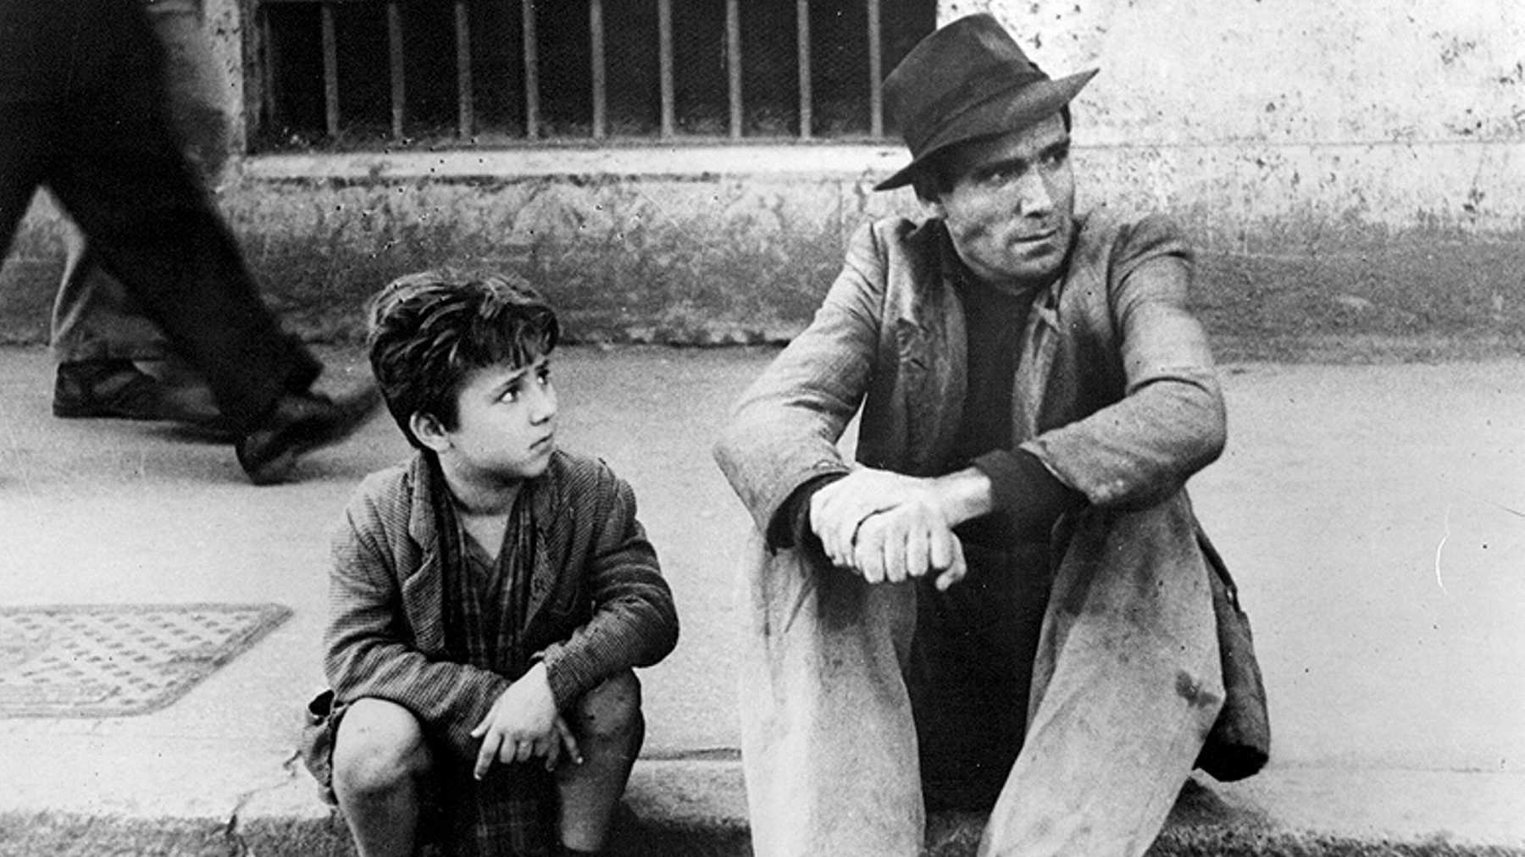
The end of the colonial era that followed the Second World War lead to a growing sense of national assertiveness as former colonies gained their independence, an attitude that was increasingly reflected in the filmmaking of these countries. Hollywood had frequently represented developing or colonised countries and their people as either exotic, tragic or threatening but from the1950s onwards filmmakers from developing or previously colonised countries began making films that challenged these stereotypes and consciously pushed against Hollywood’s style and values. These filmmakers sought to create a new kind of self-determined national cinema, one that represented their countries from within, creating films shot from the perspective of ordinary people and more directly showing the reality of their lives and experiences. Many of them were influenced by film movements such as Italian neo- realism of the1940s or the new waves of European cinema of the 1950s and aided by technological developments such as the availability of more portable camera and sound recording equipment and faster film stock that made it possible to shoot on location with a small crew and therefore cheaper and easier to make films. This period saw a flowering of filmmaking in developing countries as diverse as India, The Philippines, Senegal, Egypt, Iran, Ethiopia and Cuba. In Japan the film industry was resurgent following the Second World War and produced a string of distinctive, highly original films, quite different to those produced by the mainstream American film industry
Film to Watch:
Satyajit Ray – Pather Panchali (1955): https://www.dailymotion.com/video/x6j4i9n
Summarise the video

CHAPTER 10: French New Wave 1950’s and 1960’s

In the 1950s and 1960s, film in Europe was undergoing a transformation. Leading the way was a French film movement that became known as the French New Wave. The filmmakers of the French New Wave had taken advantage of technological developments at the end of the 1950s (lighter cameras and sound recording equipment, developments in film stock) that made it possible to shoot cheaply and easily on location, with natural light and small crews to develop a form of cinema that challenged the conventions of the established French film industry of the day. This style of filmmaking, known as “cinéma de qualité” (cinema of quality) which the directors of the French New Wave dismissed as “cinéma du papa” (dad’s or grandad’s cinema), largely focused on the production of unchallenging big budget studio shot films, often adapted from historical literary texts and made with very large crews . The directors of the French New Wave were cinema enthusiasts or cinephiles, who had grown up on the influx of American movies into Europe after the Second World War and were passionate advocates of directors from film history who had been able to produce original work and had a distinct creative style. Many directors of the French New Wave, including two of its most famous, Francois Truffaut and Jean Luc Goddard, explored ideas about film through writing articles for the influential magazine Cahiers du Cinéma. France, at the time of the French New Wave was undergoing similar social and demographic changes to other western countries and the directors of the new wave wanted to create a style of cinema and approach to narrative and mise en scene that was contemporary and relevant to the lives of the people who would watch their films. They also wanted to explore totally new ways of shooting and editing film, ways that celebrated film’s uniqueness as a medium and drew attention to its production processes rather than trying to hide them. Their films were hugely popular with young audiences and ultimately a major influence on a new generation of young Hollywood directors in the 1960s and 1970s.
Film to Watch:
Jean Luc Godard - Breathless (1960)
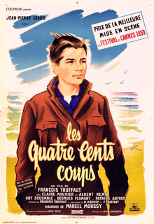
François Truffaut - 400 Blows (1958)
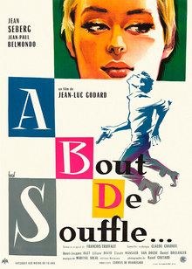

CHAPTER 11: British Social Realism (1950s and 1960s)

Social Realism was a British film movement, influenced by Italian Neo Realism and elements of the French New Wave that emerged in the1950s and 1960s. As with Neo Realism and the French New Wave, there was an emphasis on location shooting and a mobile shooting technique, the casting of unknown or non-professional actors, the use of contemporary settings and narratives, a focus on “ordinary” characters from working class or lower middle class backgrounds and often young, high levels of realism in mise-en-scene, lighting and performance and an often improvised or partly improvised approach to dialogue. The key difference between British Social Realist films and the films of the Italian Neo Realists and the French New Wave is that many of them explicitly sought to address social issues or actively bring about social change. Key British Social Realist films include: Room at the Top (1958); Saturday Night and Sunday Morning (1960); A Taste of Honey (1961); The Loneliness of the Long Distance Runner (1962); A Kind of Loving (1962); This Sporting Life (1963); Kes (1969). Many British directors, perhaps most notably Mike Leigh and Ken Loach have continued to work in a way influenced by this approach to the present day. Loach’s work in particular is characterised by an overtly political approach and an attempt to use filmmaking to bring about social change, indeed his1966 television film, ‘Cathy Come Home’ https://www.youtube.com/watch?v=xky8ZqhNAlo, about a young mother repeatedly evicted from rented accommodation, lead to the establishment of the homeless charity Shelter.
Film to Watch:
Ken Loach - Kes (1969)
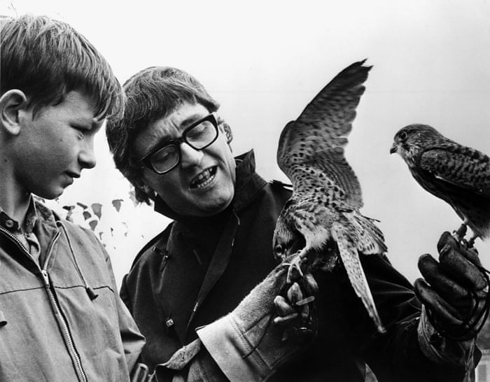

CHAPTER 12: New Hollywood (1960s and 1970s)

With audiences declining and financial problems mounting by the late 1960s, the studios had to find a way to reinvent themselves and make the films that would engage the crucial youth audience, which was an increasingly significant target for the film industry. The studios had witnessed (and largely ignored) a series of revolutions in European filmmaking from the mid-1940s onwards and the fifties and earlier sixties work of pioneering independent American producers and directors (such as Nicholas Ray, Elia Kazan, John Cassavetes, Sam Peckinpah, Sydney Lumet and Stanley Kubrick) who wanted to incorporate these new approaches to filmmaking into their own productions. The studios considered them too unusual and experimental to be appealing to American audiences. However, the box office success of a trio of American films made in the unconventional style of the European “new waves”: The Graduate (1967); Bonnie and Clyde (1967) and Easy Rider (1969), made them take notice. All three films had been producer/director lead and made on low budgets, all three had been surprisingly successful at the box office – bringing in income of around 10 times their production costs. They demonstrated to the studios that there was an appetite amongst audiences (particularly the all-important youth audience) for a more experimental approach to narrative, editing and cinematography and that a new breed of young writers, producers and directors, left to work without interference from the studios, could produce material that would unlock the studios’ access to the youth market. These three films effectively shifted the film industry away from a distribution lead approach to filmmaking and towards a production lead model and ushered in a period, lasting from about 1970 to 1980, of unprecedented levels of funding and creative freedom for filmmakers and the creation of a string of films that are considered classics today.
Film to Watch:
Martin Scorsese – Taxi Driver (1976)
THIS IS YOUR STUDY TEXT FOR FILM A LEVEL SO VERY IMPORTANT TO WATCH!
Scott - Alien (1979)

CHAPTER 13: Contemporary American Independent Film (1990-Present)

During the late 1980s and early 1990s independent production companies began to show that they were able to produce films on low budgets that could be very financially successful at the box office – the kinds of projects the mainstream American studios were unwilling to back at the time. The most significant of these companies was Miramax, set up by brothers Bob and Harvey Weinstein in 1979. It had a succession of box office hits with films such as Sex, Lies and Videotape (1989), Reservoir Dogs (1992), Clerks (1994), and Pulp Fiction (1994) and many of the films it produced and distributed were nominated for academy awards. The success of Miramax arguably created conditions that made it easier for independent filmmakers to secure funding and distribution deals for their films, it also interested the major film studios who saw that low budget independent productions had the potential to make a significant profit and bring the prestige associated with awards or award nominations. As a result, during the 1990s many of the major studios set up (or bought) their own specialty or independent divisions that specialised in making lower budget production lead films which gave their directors creative freedom with little or no studio interference.
Film to Watch:
Tarantino - Pulp Fiction (1994) https://www.youtube.com/watch?v=l37CMUicZFM
The Coen Brothers - No Country For Old Men (2007) https://www.youtube.com/watch?v=xRA_0GIDAIo
THIS IS YOUR STUDY TEXTS FOR FILM A LEVEL SO VERY IMPORTANT TO WATCH!
Ross – Captain Fantastic (2016) https://www.youtube.com/watch?v=Bz4T31kc9Sw (also currently on Netflix)
Mandatory Task 2
Task – Who is Tarantino? Creative freedom has been discussed as a key area of this period and this leads to directors developing a distinct signature style. Also known as an auteur, Tarantino has a very specific style. Can you write 700-1000 words describing what makes Tarantino an auteur. Use specific examples from a variety of films to support your answer.
https://vimeo.com/195542533 - This will really help!
………………………………………………………………………………………………………………………………………………………………………………………………………………………………………………………………………………………………………………………………………………………………………………………………………………………………………………………………………………………………………………………………………………………………………………………………………………………………………………………………………………………………………………………………………………………………………………………………………………………………………………………………………………………………………………………………………………………………………………………………………………………………………………………………………………………………………………………………………………………………………………………………………………………………………………………………………………………………………………………………………………………………………………………………………………………………………………………………………………………………………………………………………………………………………………………………………………………………………………………………………………………………………………………………………………………………………………………………………………………………………………………………………………………………………………………………………………………………………………………………………………………………………………………………………………………………………………………………………………………………………………………………………………………………………………………………………………………………………………………………………………………………………………………………………………………………………………………………………………………………………………………………………………………………………………………………………………………………………………………………………………………………………………………………………………………………………………………………………………………………………………………………………………………………………………………………………………………………………………………………………………………………………………………………………………………………………………………………………………………………………………………………………………………………………………………………………………………………………………………………………………………………………………………………………………………………………………………………………………………………………………………………………………………………………………………………………………………………………………………………………………………………………………………………………………………………………………………………………………………………………………………………………………………………………………………………………………………………………………………………………………………………………………………………………………………………………………………………………………………………………………………………………………………………………………………………………………………………………………………………………………………………………………………………………………………………………………………………………………………………………………………………………………………………………………………………………………………………………………………………………………………………………………………………………………………………………………………………………………………………………………………………………………………………………………………………………………………………………………………………………………………………………………………………………………………………………………………………………………………………………………………………………………………………………………………………………………………………………………………………………………………………………………………………………………………………………………………………………………………………………………………………………………………………………………………………………………………………………………………………………………………………………………………………………………………………………………………………………………………………………………………………………………………………………………………………………………………………………………………………………………………………………………………………………………………………………………………………………………………………………………………………………………………………………………………………………………………………………………………………………………………………………………………………………………………………………………………………………………………………………………………………………………………………………………………………………………………………………………………………………………………………………………………………………………………………………………………………………………………………………………………………………………………………………………………………………………………………………………………………………………………………………………………………………………………………………………………………………………………………………………………………………………………………………………………………………………………………………………………………………………………………………………………………………………………………………………………………………………………………………………………………………………………………………………………………………………………………………………………………………………………………………………………………………………………………………………………………………………………………………………………………………………………………………………………………………………………………………………………………………………………………………………………………………………………………………………………………………………………………………………………………………………………………………………………………………………………………………………………………………………………………………………………………………………………………………………………………………………………………………………………………………………………………………………………………………………………………………………………………………………………………………………………………………………………………………………………………………………………………………………………………………………………………………………………………………………………………………………………………………………………………………………………………………………………………………………………………………………………………………………………………………………………………………………………………………………………………………………………………………………………………………………………………………………………………………………………………………………………………………………………………………………………………………………………………………………………………………………………………………………………………………………………………………………………………………………………………………………………………………………………………………………………………………………………………………………………………………………………………………………………………………………………………………………………………………………………………………………………………………………………………………………………………………………………………………………………………………………………………………………………………………………………………………………………………………………………………………………………………………………………………………………………………………………………………………………………………………………………………………………………………………………………………………………………………………………………………………………………………………………………………………………………………………………………………………………………………………………………………………………………………………………………………………………………………………………………………………………………………………………………………………………………………………………………………………………………………………………………………………………………………………………………………………………………………………………………………………………………………………………………………………………………………………………………………………………………………………………………………………………………………………………………………………………………………………………………………………………………………………………………………………………………………………………………………………………………………………………………………………………………………………………………………………………………………………………………………………………………………………………………………………………………………………………………………………………………………………………………………………………………………………………………………………………………………………………………………………………………………………………………………………………………………………………………………………………………………………………………………………………………………………………………………………………………………………………………………………………………………………………………………………………………………………………………………………………………………………………………………………………………………………………………………………………………………………………………………………………………………………………………………………………………………………………………………………………………………………………………………………………………………………………………………………………………………………………………………………………………………………………………………………………………………………………………………………………………………………………………………………………………………………………………………………………………………………………………………………………………………………………………………………………………………………………………………………………………………………………………………………………………………………………………………………………………………………………………………………………………………………………………………………………………………………………………………………………………………………………………………………………………………………………………………………………………………………………………………………………………………………………………………………………………………………………………………………………………………………………………………………………………………………………………………………………………………………………………………………………………………………………………………………………………………………………………………………………………………………………………………………………………………………………………………………………………………………………………………………………………………………………………………………………………………………………………………………………………………………………………………………………………………………………………………………………………………………………………………………………………………………………………………………………………………………………………………………………………………………………………………………………………………………………………………………………………………………………………………………………………………………………………………………………………………………………………………………………………………………………………………………………………………………………………………………………………………………………………………………………………………………………………………………………………………………………………………………………………………………………………………………………………………………………………………………………………………………………………………………………………………………………………………………………………………………………………………………………………………………………………………………………………………………………………………………………………………………………………………………………………………………………………………………………………………………………………………………………………………………………………………………………………………………………………………………………………………………………………………………………………………………………………………………………………………………………………………………………………………………………………………………………………………………………………………………………………………………………………………………………………………………………………………………………………………………………………………………………………………………………………………………………………………………………………………………………………………………………………………………………………………………………………………………………………………………………………………………………………………………………………………………………………………………………………………………………………………………………………………………………………………………………………………………………………………………………………………………………………………………………………………………………………………………………………………………………………………………………………………………………………………………………………………………………………………………………………………………………………………………………………………………………
CHAPTER 14: Contemporary European Film (1990 – Present)

Many of film’s earliest innovations were European, and in the first decade or so of the film industry many of the most powerful and significant film studios and production companies were European. Gradually the balance of power began to shift to a point where, by the mid-1910s, film became an industry dominated by American companies, something that has persisted to the present day. As with the contemporary British film industry, in comparison to the studio dominated approach of America the contemporary European film industry is smaller in scale and largely production lead. It’s hard to get figures that demonstrate the size of the European film industry as a whole, although we can find them for individual European countries. For example, compared to the American film industry which generated approximately $25 billion in revenue in 2018, the French and German film industries generated approximately £3 billion of revenue each in the same year with the Italian and Spanish industries generating approximately £1 billion apiece. As with the British film industry, the film industries of European countries tend to be structured in very different way to the mainstream, vertically integrated American film industry Rather than being distribution lead and commercially driven they tend to be largely production lead, with filmmakers or production companies developing productions before securing finance or distribution deals and having to source funding from a range of providers to put their films into production. There are many European companies and organisations that provide funding to European filmmakers, perhaps most notably the EU organisation Creative Europe which, through its media programme has a role similar to the BFI in the UK in funding filmmakers. While we need to be careful about making simplistic generalisations about the nature of films produced by different national film industries it could be argued that the smaller scale and production lead and less commercially driven nature of the European film industry allows some filmmakers opportunities to work in more experimental or unconventional ways, something that is certainly the case with .Victoria
Film to Watch:
Florian Henckel von Donnersmarck – The Lives of Others (2006)
THESE ARE YOUR STUDY TEXTS FOR FILM A LEVEL SO VERY IMPORTANT TO WATCH!
Wright - Shaun of the Dead (2004) https://www.youtube.com/watch?v=s1eIvOTh6cg
Boyle – Trainspotting (1995) https://www.youtube.com/watch?v=PH3WegABYdM

CHAPTER 15: Documentary Film (1895-Present)

Documentaries have had a place in film history since the beginning of the medium at the turn of the Twentieth Century. Indeed, although the term hadn’t been coined at the time that they were made, some of the earliest films ever made could be classified as forms of documentary. Since then documentary has evolved as a form of filmmaking, developing a range of conventions and characteristics and being especially affected by and responsive to technological change.
Film to Watch:
Longhinotto – Divorce, Iranian Style (1998) https://www.youtube.com/watch?v=yYaRb070r8E
Michael Moore - Where to Invade Next (2015)
Rumble (2020) https://www.youtube.com/watch?v=ec4pEP9-Mrg
THIS IS YOUR STUDY TEXT FOR FILM A LEVEL SO VERY IMPORTANT TO WATCH!
Kapadia – Amy (2015) https://www.youtube.com/watch?v=AdMmoHVpqg4


Scene Analysis and Film Form
Film form is one of the key areas required for each of the films you study. Film form covers aspects surrounding cinematography, editing, sound and mise-en-scene. It is vital that you hold a key understanding of these areas and in specific reference to the films we are studying.
Below are key areas of the media hub for you to explore in order to add knowledge and further examples to this.
Film Form Examples
https://www.churchdownmediahub2.com/film-form.html


Contextual Development
Adding specific examples to each film can be found at the bottom of most film web pages on the media hub. Watch videos and make notes on them for use during your course.
https://www.churchdownmediahub2.com/pulp-fiction.html
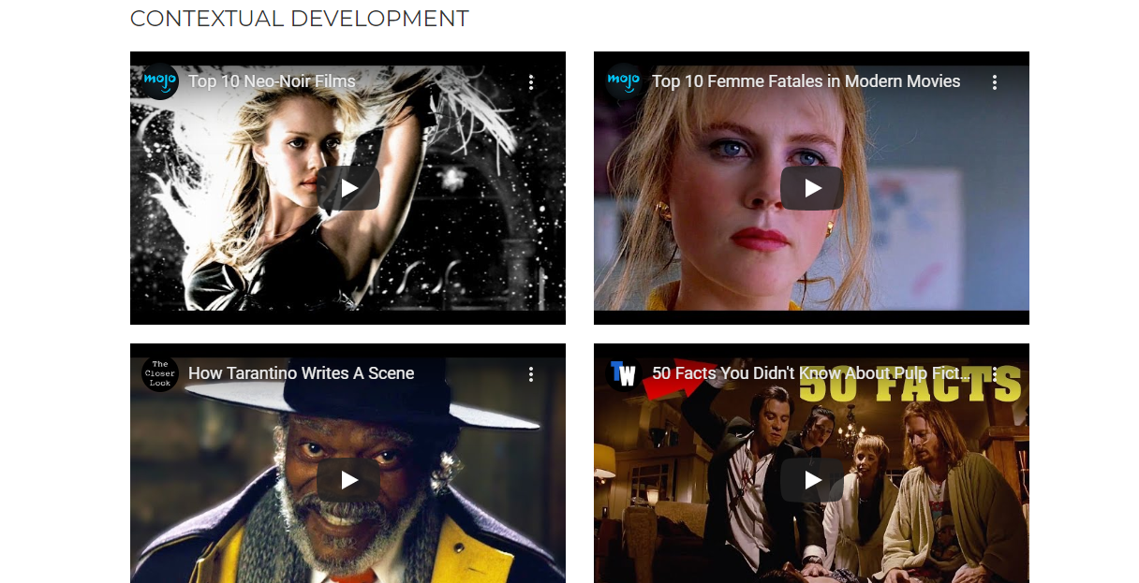

The following table lists a selection of some of the film form techniques you must be able to apply to all films that we study. Film form is extremely important. Research the range of techniques in the table below with examples. Specifically focus on the definition of each technique (what it looks like) and what it could mean for the audience when used in a film. Remember this meaning will vary depending on the context of the specific scene.
Cinematography | Editing
Camera Angles  Birdseye View, High Angle, Low Angle, Wormseye View  Camera Shots  Extreme Close Up, Close Up, Medium Close Up, Mid Shot, Medium Long Shot, Extreme Long Shot  Camera Movements  Hand Held, Pan, Tilt, Crane, Ariel, Track | Cut  Shot reverse shot  Cross cut  Eyeline match  Montage  Match Cut  180 degree rule
Sound | Mise-En-Scene
Diegetic sound  Non diegetic sound  Parallel sound  Contrapuntal sound  Ambient Sound | Setting/Location  Props  Performance  Costume/Make up  Positioning  Colour  Lighting

Mandatory Task 3 – Scene Analysis
Look at the clip in the link below. Using the knowledge you have gained from your research can you provide an analysis of some of the techniques used in the clip. Try to aim for 5 examples.
For each example you must follow the following success criteria…
Success Criteria
Targets |  | Possible sentence starters
T1 | Identify the technique you wish to talk about in the scene that has been used to create meaning for the audience. | One elements of ……… used in the scene is…  Another element used to communicate meaning is…
T2 | Discuss what meaning it conveys to the audience. How does it make them feel? Try to give various meanings. Think about how we are supposed to feel about the characters in the scene but also the overall narrative itself. | This makes the audience think…  This makes the audience feel…  This suggests…  This makes you think the character is…
T3 | Does this technique work in conjunction with another? For example does a facial expression (performance mise-en-scene) that you have discussed in your paragraph work with some dialogue?. | This works well with another example of…  These combine to make the audience feel…  This is supported by the use of…

Captain Fantastic - https://www.youtube.com/watch?v=dXE6ZafkRMI
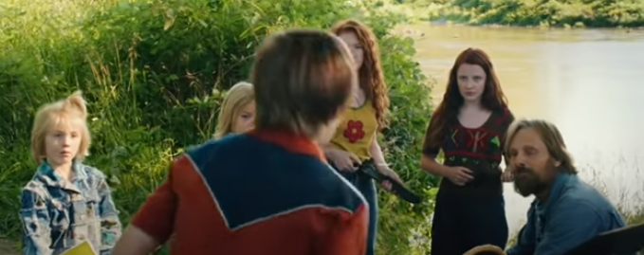

A reminder that this link https://www.churchdownmediahub2.com/film-form.html coupled with your own research will help.
…………………………………………………………………………………………………………………………………………………………………………………………………………………………………………………………………………………………………………………………………………………………………………………………………………………………………………………………………………………………………………………………………………………………………………………………………………………………………………………………………………………………………………………………………………………………………………………………………………………………………………………………………………………………………………………………………………………………………………………………………………………………………………………………………………………………………………………………………………………………………………………………………………………………………………………………………………………………………………………………………………………………………………………………………………………………………………………………………………………………………………………………………………………………………………………………………………………………………………………………………………………………………………………………………………………………………………………………………………………………………………………………………………………………………………………………………………………………………………………………………………………………………………………………………………………………………………………………………………………………………………………………………………………………………………………………………………………………………………………………………………………………………………………………………………………………………………………………………………………………………………………………………………………………………………………………………………………………………………………………………………………………………………………………………………………………………………………………………………………………………………………………………………………………………………………………………………………………………………………………………………………………………………………………………………………………………………………………………………………………………………………………………………………………………………………………………………………………………………………………………………………………………………………………………………………………………………………………………………………………………………………………………………………………………………………………………………………………………………………………………………………………………………………………………………………………………………………………………………………………………………………………………………………………………………………………………………………………………………………………………………………………………………………………………………………………………………………………………………………………………………………………………………………………………………………………………………………………………………………………………………………………………………………………………………………………………………………………………………………………………………………………………………………………………………………………………………………………………………………………………………………………………………………………………………………………………………………………………………………………………………………………………………………………………………………………………………………………………………………………………………………………………………………………………………………………………………………………………………………………………………………………………………………………………………………………………………………………………………………………………………………………………………………………………………………………………………………………………………………………………………………………………………………………………………………………………………………………………………………………………………………………………………………………………………………………………………………………………………………………………………………………………………………………………………………………………………………………………………………………………………………………………………………………………………………………………………………………………………………………………………………………………………………………………………………………………………………………………………………………………………………………………………………………………………………………………………………………………………………………………………………………………………………………………………………………………………………………………………………………………………………………………………………………………………………………………………………………………………………………………………………………………………………………………………………………………………………………………………………………………………………………………………………………………………………………………………………………………………………………………………………………………………………………………………………………………………………………………………………………………………………………………………………………………………………………………………………………………………………………………………………………………………………………………………………………………………………………………………………………………………………………………………………………………………………………………………………………………………………………………………………………………………………………………………………………………………………………………………………………………………………………………………………………………………………………………………………………………………………………………………………………………………………………………………………………………………………………………………………………………………………………………………………………………………………………………………………………………………………………………………………………………………………………………………………………………………………………………………………………………………………………………………………………………………………………………………………………………………………………………………………………………………………………………………………………………………………………………………………………………………………………………………………………………………………………………………………………………………………………………………………………………………………………………………………………………………………………………………………………………………………………………………………………………………………………………………………………………………………………………………………………………………………………………………………………………………………………………………………………………………………………………………………………………………………………………………………………………………………………………………………………………………………………………………………………………………………………………………………………………………………………………………………………………………………………………………………………………………………………………………………………………………………………………………………………………………………………………………………………………………………………………………………………………………………………………………………………………………………………………………………………………………………………………………………………………………………………………………………………………………………………………………………………………………………………………………………………………………………………………………………………………………………………………………………………………………………………………………………………………………………………………………………………………………………………………………………………………………………………………………………………………………………………………………………………………………………………………………………………………………………………………………………………………………………………………………………………………………………………………………………………………………………………………………………………………………………………………………………………………………………………………………………………………………………………………………………………………………………………………………………………………………………………………………………………………………………………………………………………………………………………………………………………………………………………………………………………………………………………………………………………………………………………………………………………………………………………………………………………………………………………………………………………………………………………………………………………………………………………………………………………………………………………………………………………………………………………………………………………………………………………………………………………………………………………………………………………………………………………………………………………………………………………………………………………………………………………………………………………………………………………………………………………………………………………………………………………………………………………………………………………………………………………………………………………………………………………………………………………………………………………………………………………………………………………………………………………………………………………………………………………………………………………………………………………………………………………………………………………………………………………………………………………………………………………………………………………………………………………………………………………………………………………………………………………………………………………………………………………………………………………………………………………………………………………………………………………………………………………………………………………………………………………………………………………………………………………………………………………………………………………………………………………………………………………………………………………………………………………………………………………………………………………………………………………………………………………………………………………………………………………………………………………………………………………………………………………………………………………………………………………………………………………………………………………………………………………………………………………………………………………………………………………………………………………………………………………………………………………………………………………………………………………………………………………………………………………………………………………………………………………………………………………………………………………………………………………………………………………………………………………………………………………………………………………………………………………………………………………………………………………………………………………………………………………………………………………………………………………………………………………………………………………………………………………………………………………………………………………………………………………………………………………………………………………………………………………………………………………………………………………………………………………………………………………………………………………………………………………………………………………………………………………………………………………………………………………………………………………………………………………………………………………………………………………………………………………………………………………………………………………………………………………………………………………………………………………………………………………………………………………………………………………………………………………………………………………………………………………………………………………………………………………………………………………………………………………………………………………………………………………………………………………………………………………………………………………………………………………………………………………………………………………………………………………………………………………………………………………………………………………………………………………………………………………………………………………………………………………………………………………………………………………………………………………………………………………………………………………………………………………………………………………………………………………………………………………………………………………………………………………………………………………………………………………………………………………………………………………………………………………………………………………………………………………………………………………………………………………………………………………………………………………………………………………………………………………………………………………………………………………………………………………………………………………………………………………………………………………………………………………………………………………………………………………………………………………………………………………………………………………………………………………………………………………………………………………………………………………………………………………………………………………………………………………………………………………………………………………………………………………………………………………………………………………………………………………………………………………………………………………………………………………………………………………………………………………………………………………………………………………………………………………………………………………………………………………………………………………………………………………………………………………………………………………………………………………………………………………………………………………………………………………………………………………………………………………………………………………………………………………………………………………………………………………………………………………………………………………………………………………………………………………………………………………………………………………………………………………………………………………………………………………………………………………………………………………………………………………………………………………………………………………………………………………………………………………………………………………………………………………………………………………………………………………………………………………………………………………………………………………………………………………………………………………………………………………………………………………………………………………………………………………………………………………………………………………………………………………………………………………………………………………………………………………………………………………………………………………………………………………………………………………………………………………………………………………………………………………………………………………………………………………………………………………………………………………………………………………………………………………………………………………………………………………………………………………………………………………………………………………………………………………………………………………………………………………………………………………………………………………………………………………………………………………………………………………………………………………………………………………………………………………………………………………………………………………………………………………………………………………………………………………………………………………………………………………………………………………………………………………………………………………………………………………………………………………………………………………………………………………………………………………………………………………………………………………………………………………………………………………………………………………………………………………………………………………………………………………………………………………………………………………………………………………………………………………………………………………………………………………………………………………………………………………………………………………………………………………………………………………………………………………………………………………………………………………………………………………………………………………………………………………………………………………………………………………………………………………………………………………………………………………………………………………………………………………………………………………………………………………………………………………………………………………………………………………………………………………………………………………………………………………………………………………………………………………………………………………………………………………………………………………………………………………………………………………………………………………………………………………………………………………………………………………………………………………………………………………………………………………………………………………………………………………………………………………………………………………………………………………………………………………………………………………………………………………………………………………………………………………………………………………………………
Contextual Development – Wider Reading
As a media student is essential that you develop your independent learning skills and carry out wider reading around your subject. Here is a list of books and websites which will help you prepare for the theoretical aspect of the Media Studies course
Eduqas
https://resources.eduqas.co.uk/pages/ResourceByArgs?subId=50
Please read through the eduqas resources section many of these we will use in class so feel free to look at them and being your pre-reading.

Websites
The Media Guardian: https://www.theguardian.com/uk/media
EMC’s Media Magazine: https://www.englishandmedia.co.uk/media-magazine (well worth subscribing to – we have hard copies delivered to school available to loan from MD1)
British Film Institute: http://www.bfi.org.uk/
Eduqas Qualification Page : https://www.eduqas.co.uk/qualifications/film-studies-as-a-level/#tab_overview
Churchdown Media Hub: https://www.churchdownmediahub2.com/
(Password – churchdownmediahub)
Contextual Development – Wider Watching
It seems mad people would opt to do a course without a keen interest in the subject. Especially film! I love films! It would greatly help if you did too…anything else related to the to film. Your own experiences and engagements with the film will feed in to the topics we cover and help you to apply theories and course content in different contexts.
Many people ask me to recommend films to watch that will help them in the course. Here is a list of films I enjoy or find that they challenge ideology or conventions in some way. Watch any of these for some good discussions to be had in the future. I always have more if you plough through these. Happy watching. (Age restrictions may apply)
- Fight Club
- Shutter Island
- Batman the Dark Knight
- The Joker
- Looper
- Reservoir dogs
- Kingdom of Heaven
- Eternal Sunshine of the Spotless Mind
- 23
- The Truman Show
- Stranger Than Fiction
- Momento
- Inception
- Pulp Fiction
- Forrest Gump
- The Matrix
- Seven
- Saving Private Ryan
- The Departed
- The Prestige
- Whiplash
- Sixth Sense
- Back to the Future
- Indiana Jones – The Last Crusade
- Minority Report

